**Deploy an ASP.NET WebForms Application on Azure**

**Practice Project**

**Aim:**

To build an existing ASP.NET WebForms application locally and deploy it to a VM on Azure.

**GitHub Link:**

[**https://github.com/Sukirthalakshmanan1/Azure**](https://github.com/Sukirthalakshmanan1/Azure)

**Procedure:**

* Open the Webforms project and run it in IIS after successful launch.
* Publish web application.
* Select Target Azure 🡪Azure App service then sign in with your Azure pass.
* Create new App service and click create.
* After successful creation click publish.
* And in Web config add <customErrors mode="Off"/>
* Then the WebForm application Runs.

**Azure Site URL :**

https://webapplication420221101161814.azurewebsites.net

**Output:**

**Home Page:**

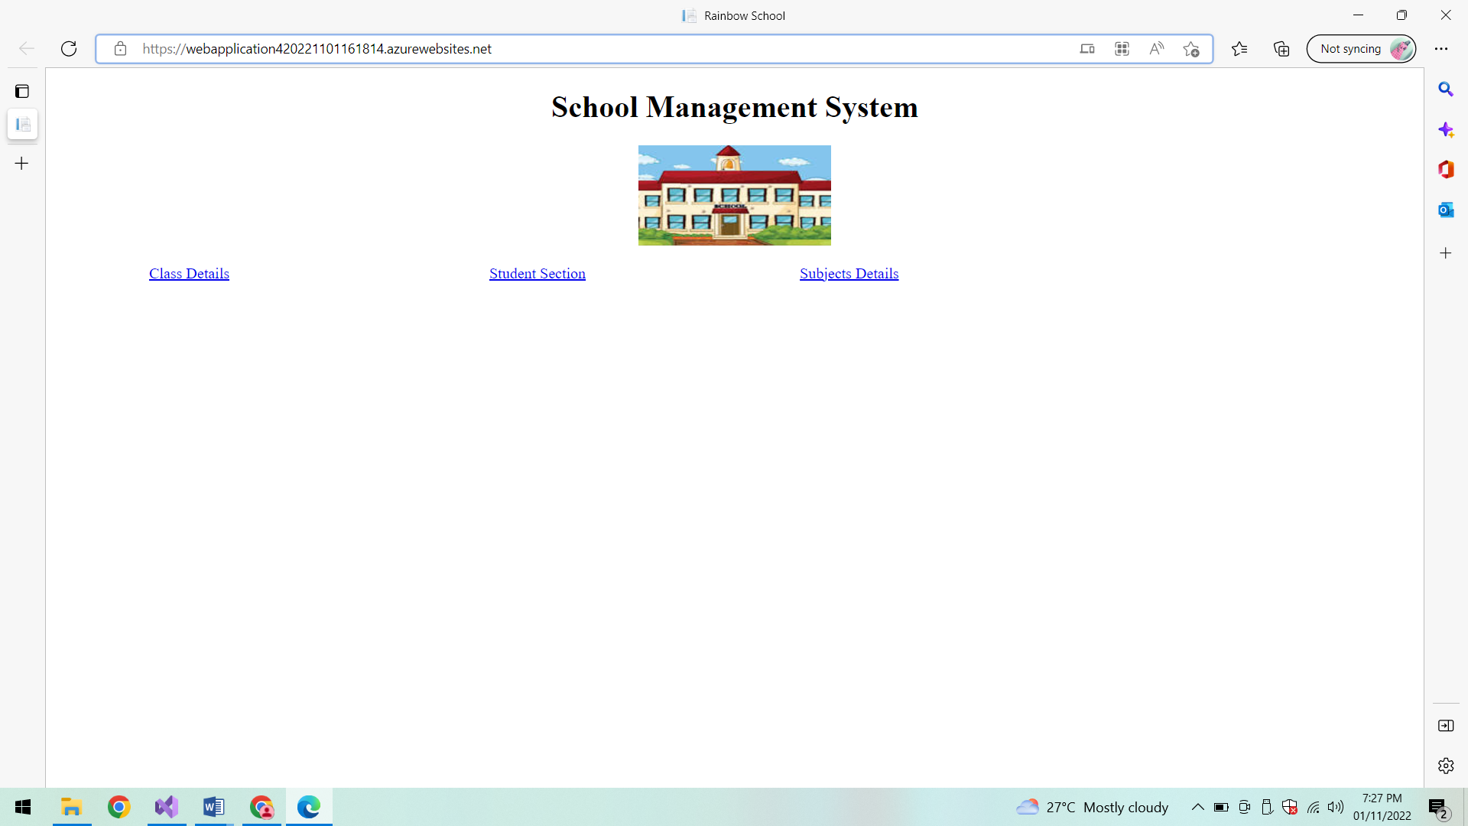

**Class Details:**

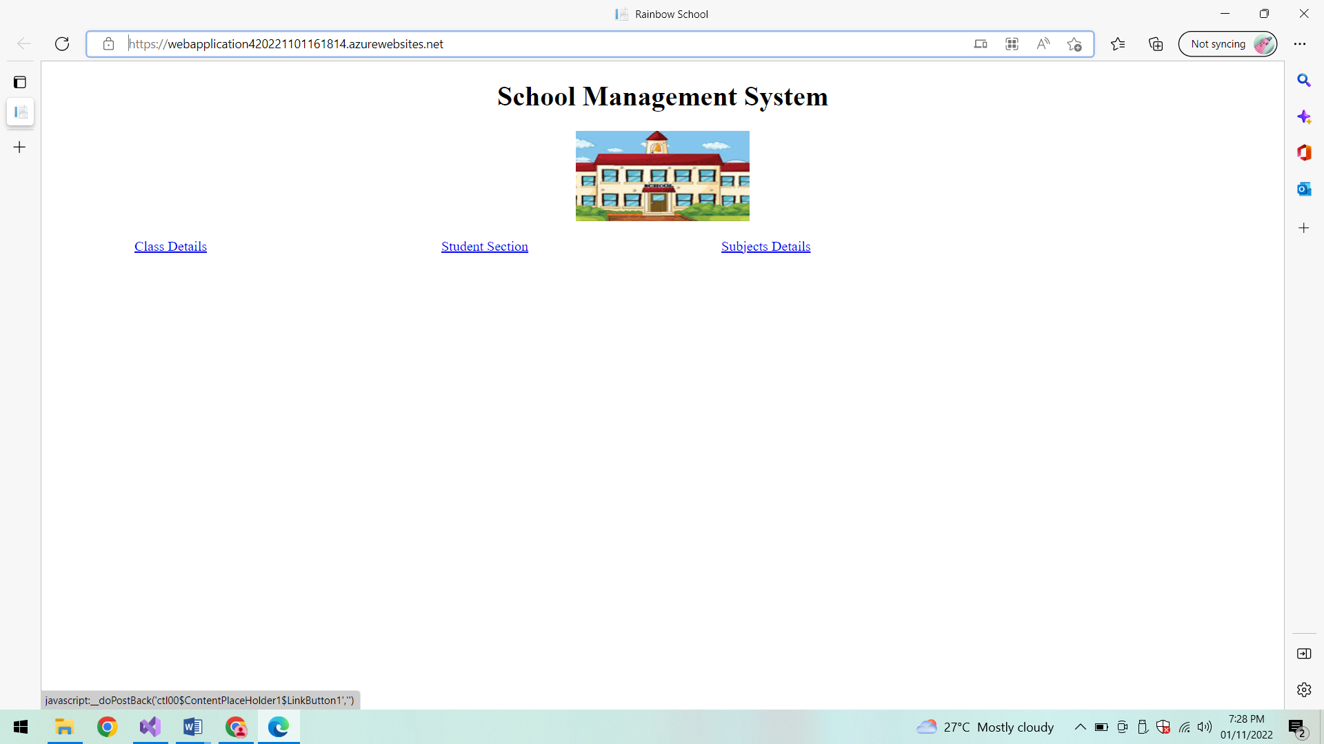

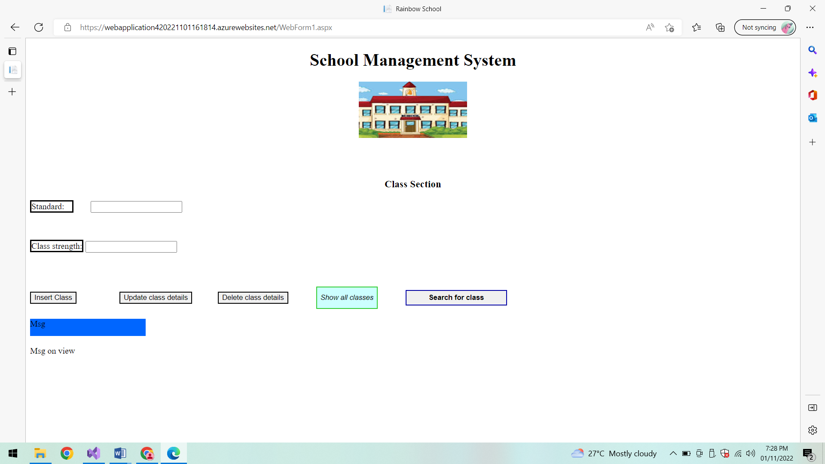

**Show all classes:**

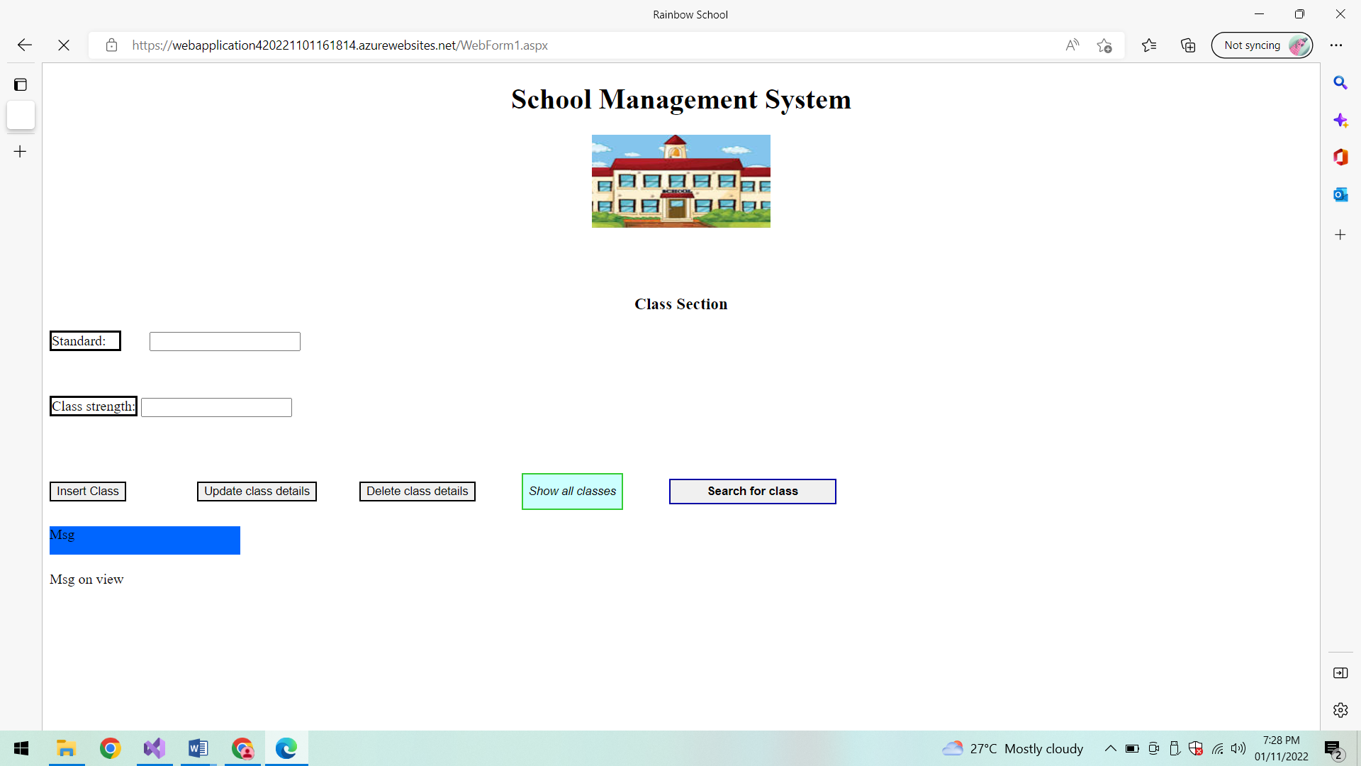

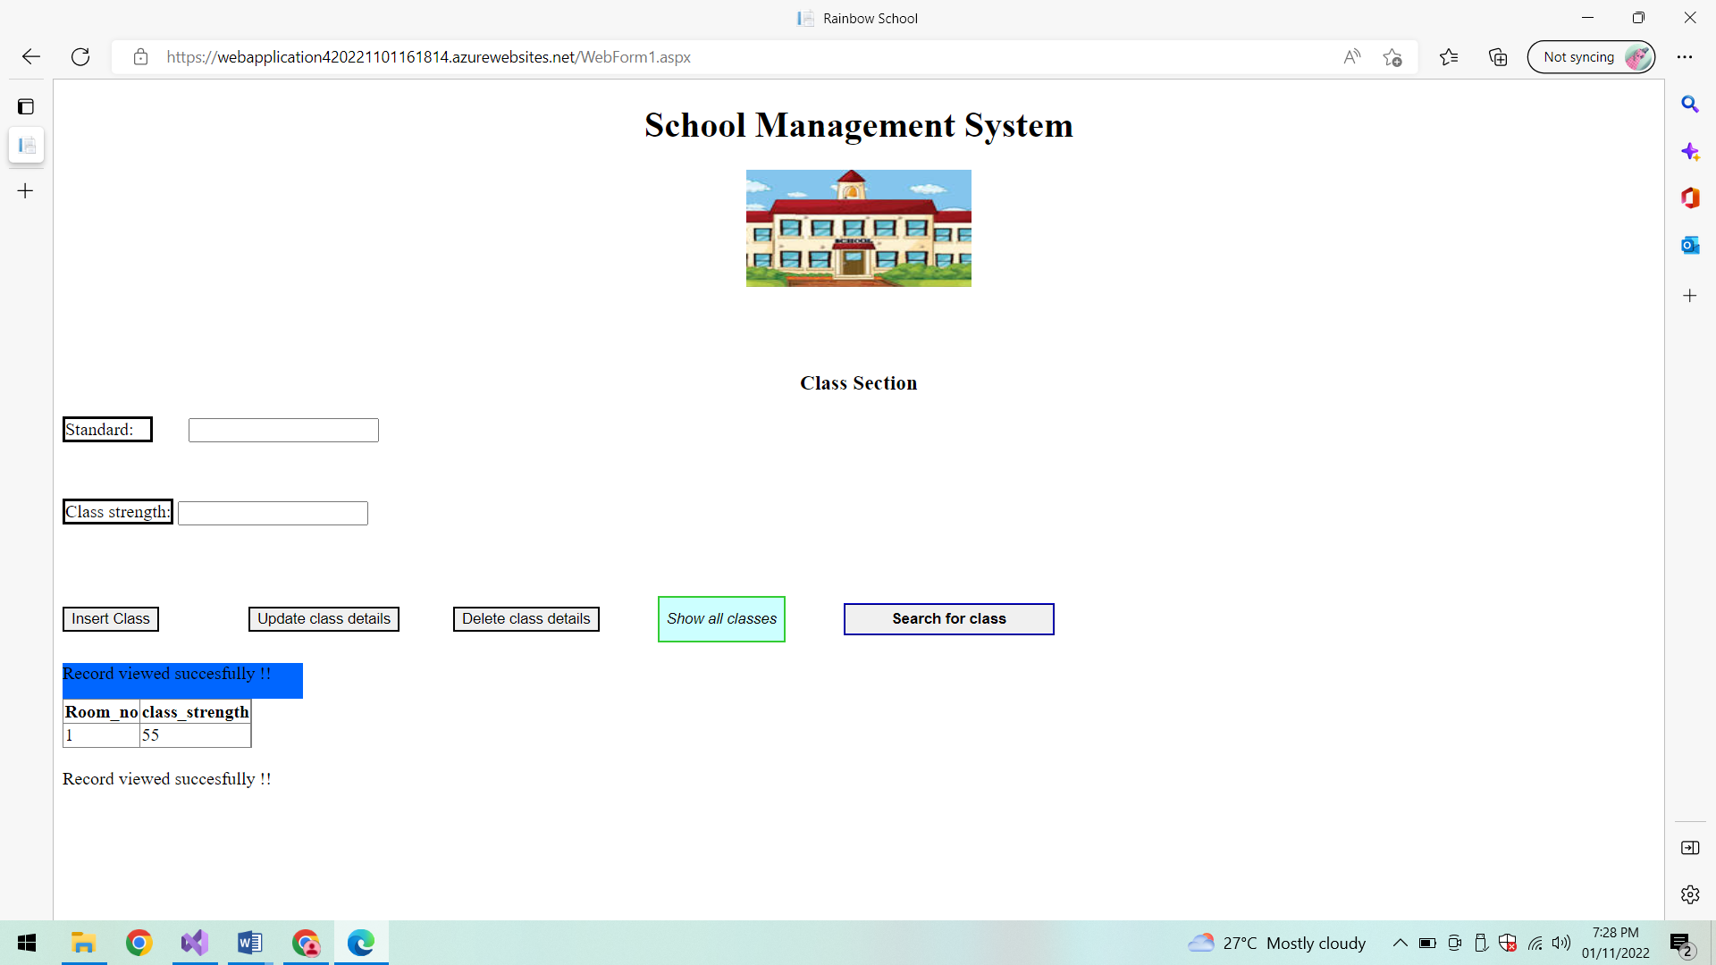

**Insert Class:**

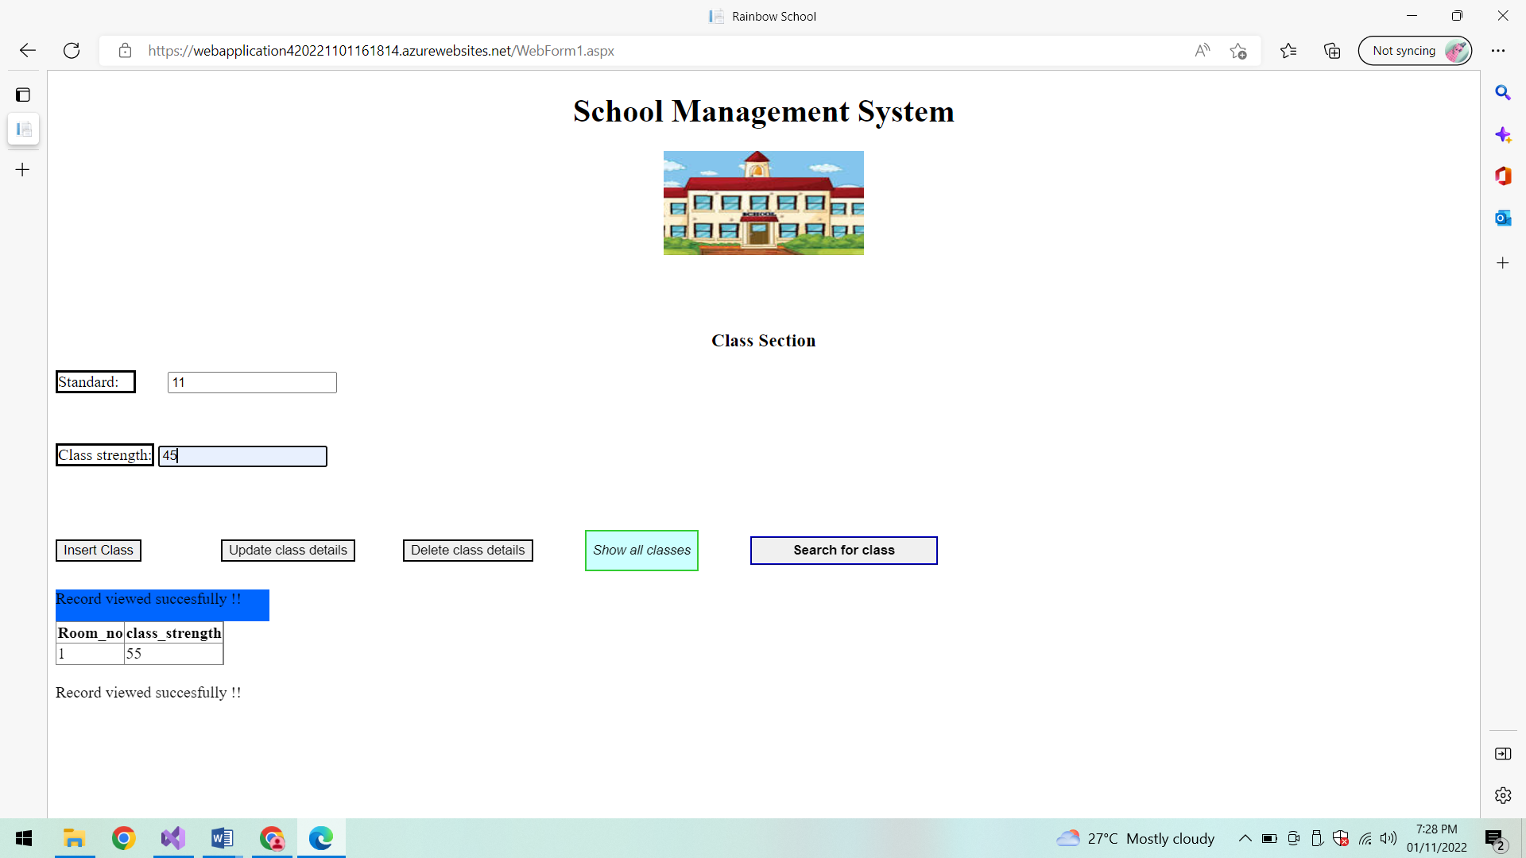

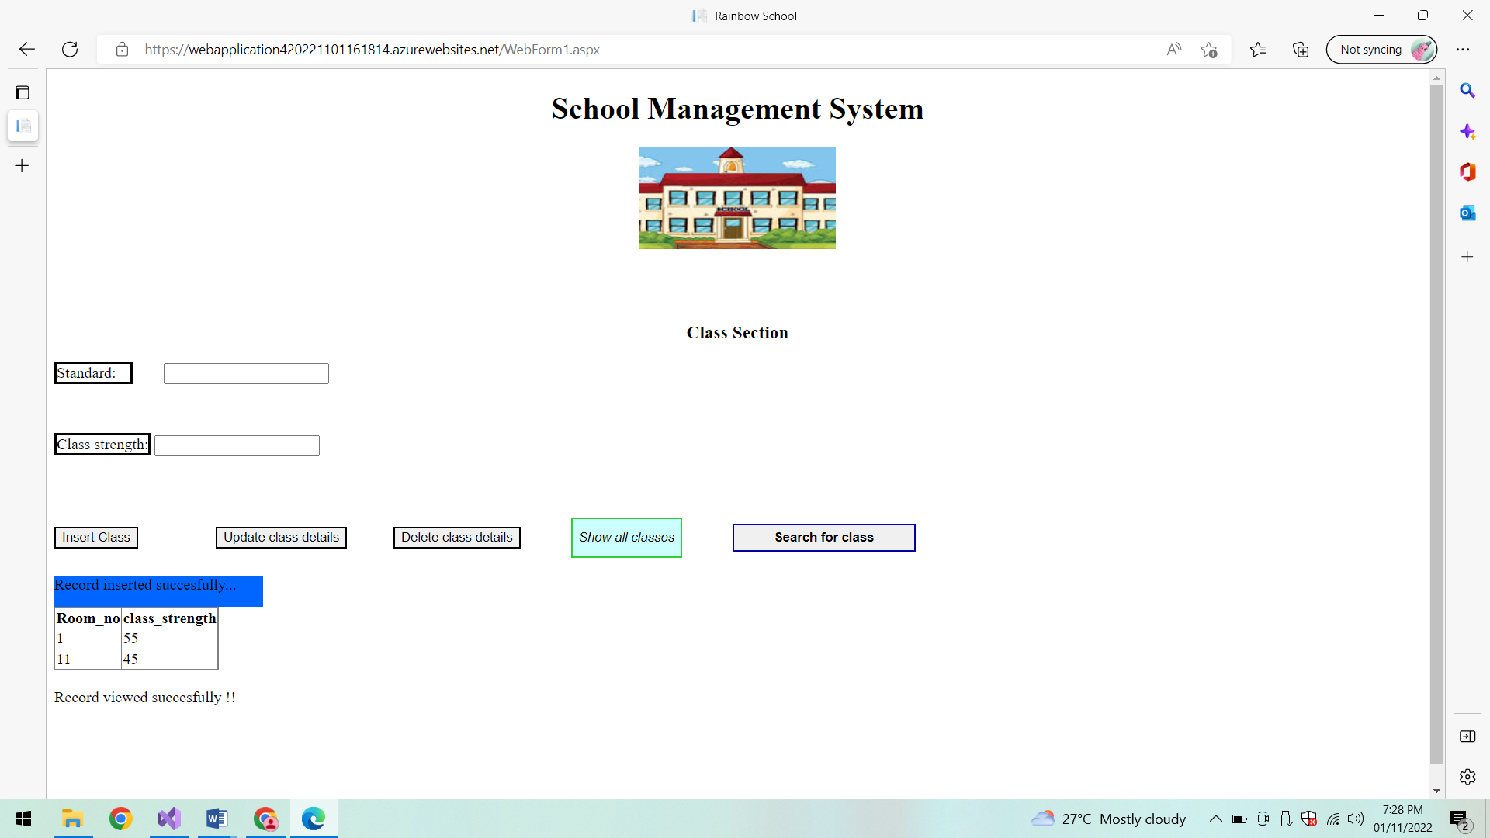

**Update Class:**

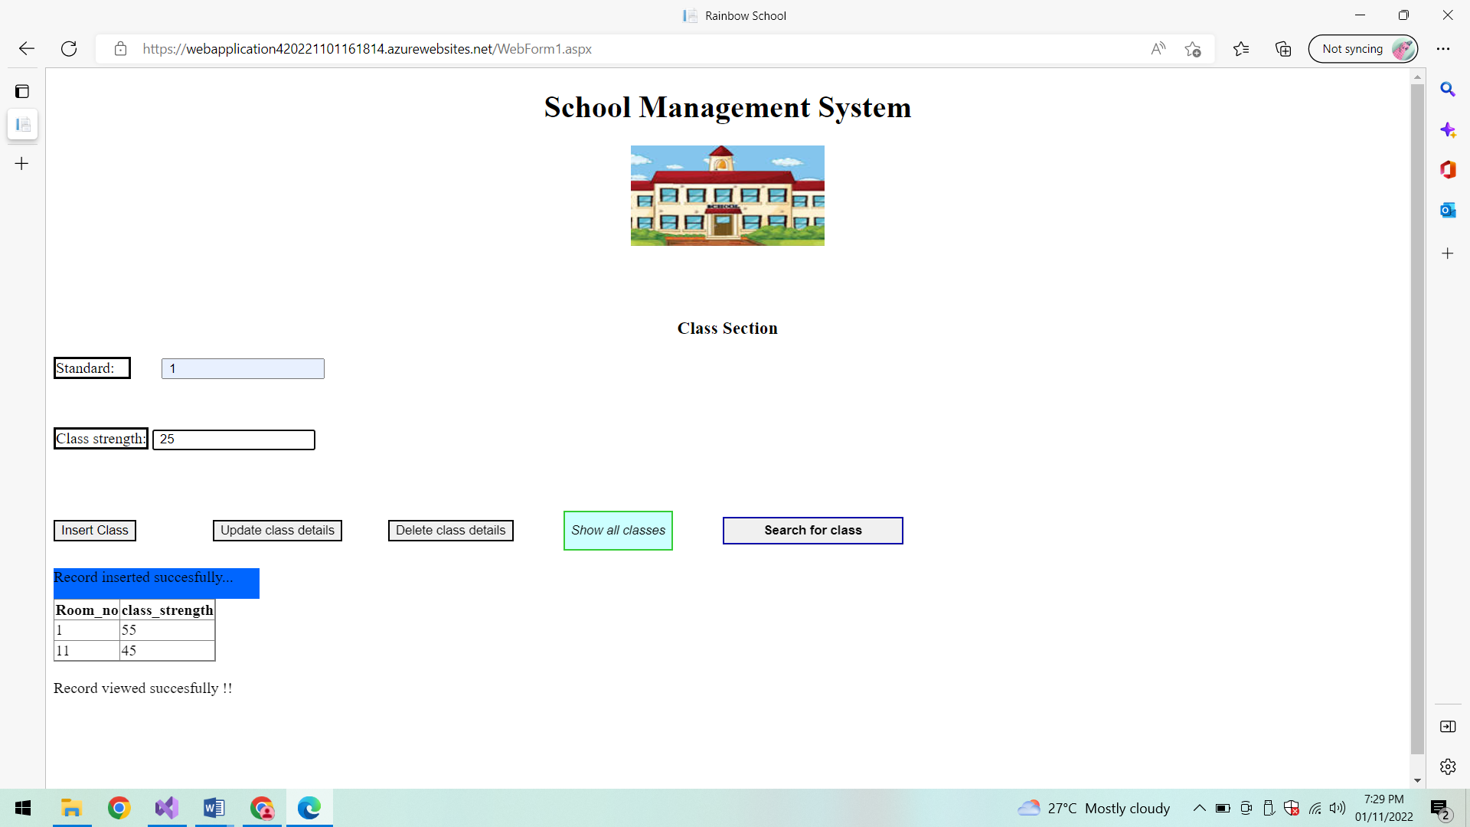

**Class updated successfully:**

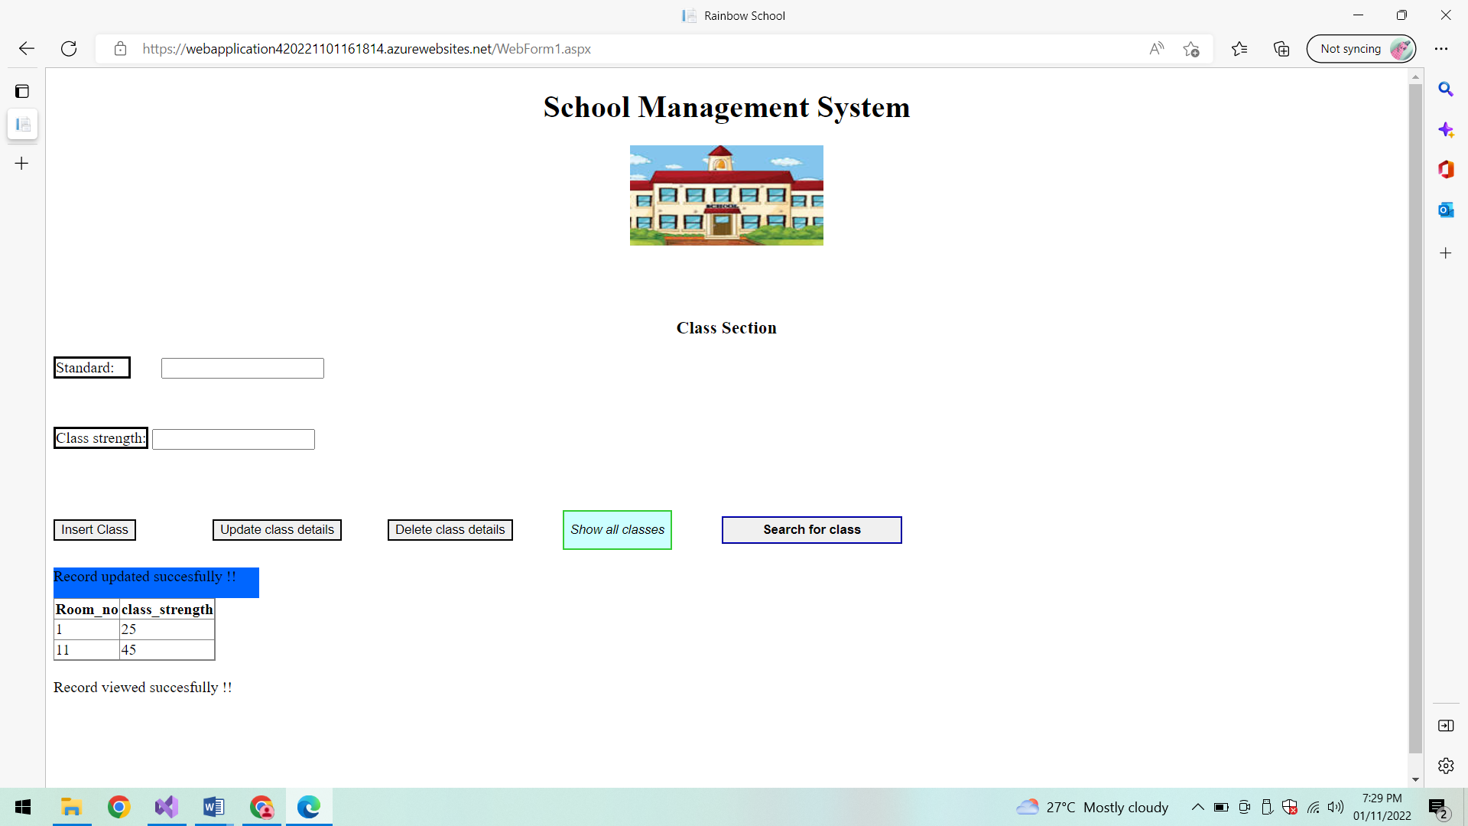

**Delete class details:**

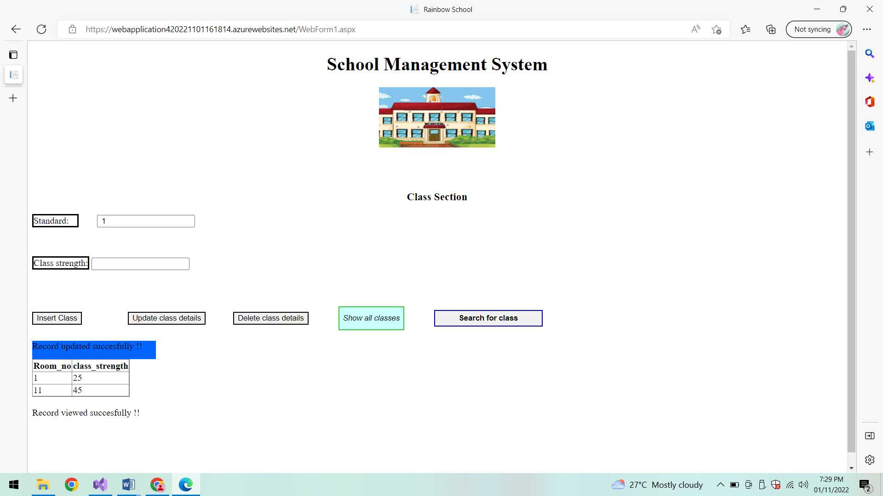

**After deletion:**

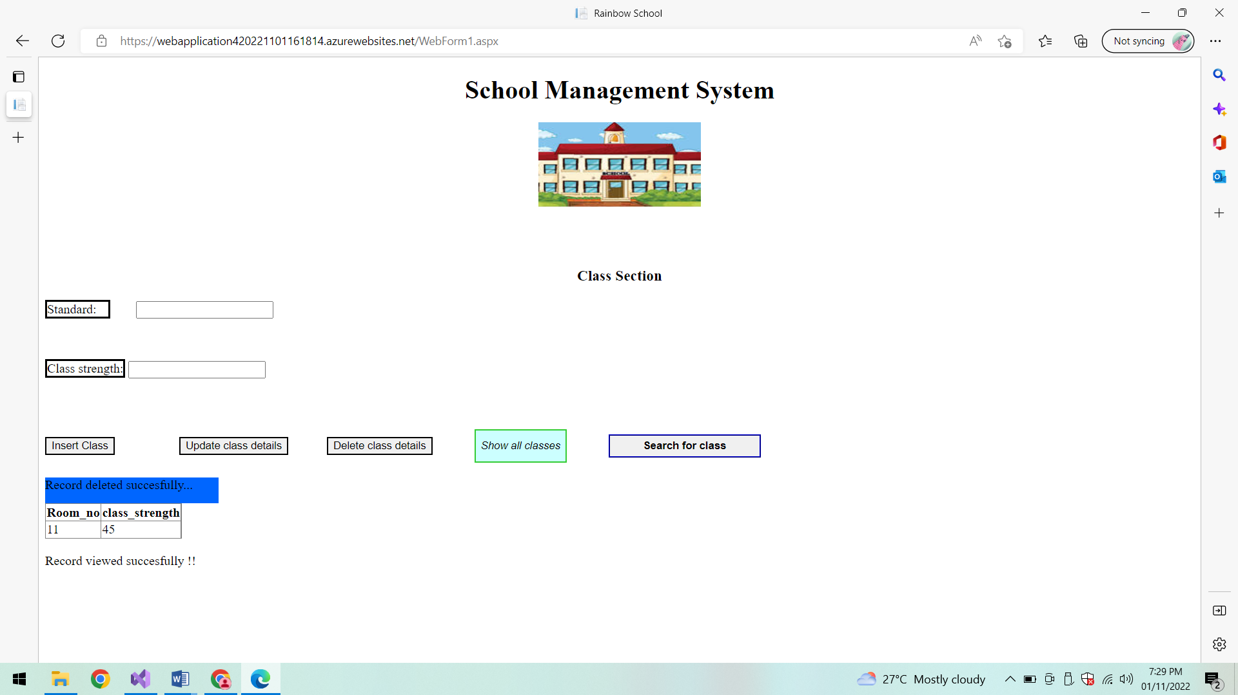

**Show all classes:**

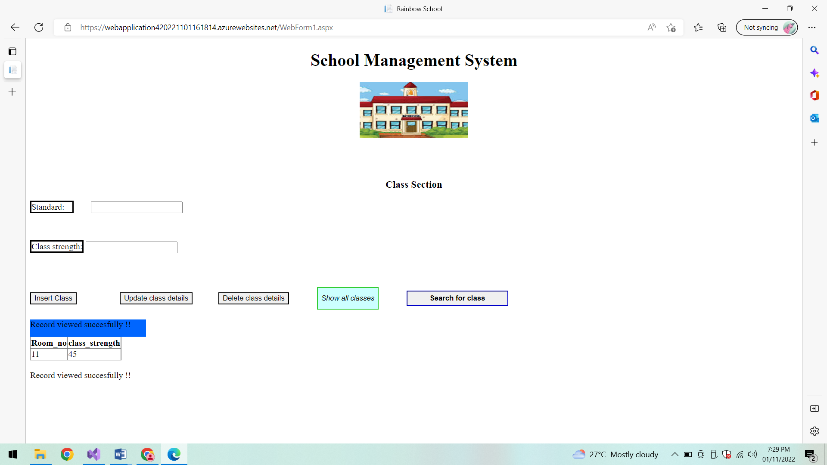

**Search for class:**

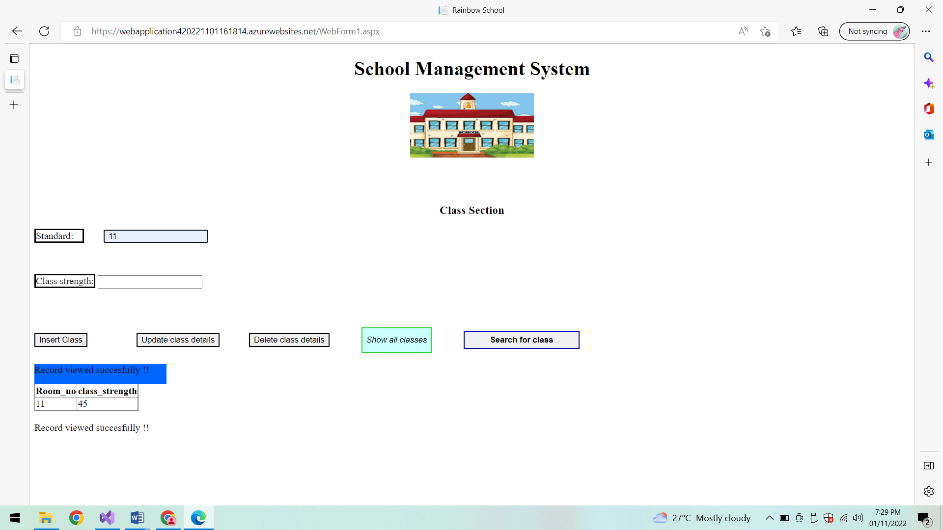

**Class Found:**

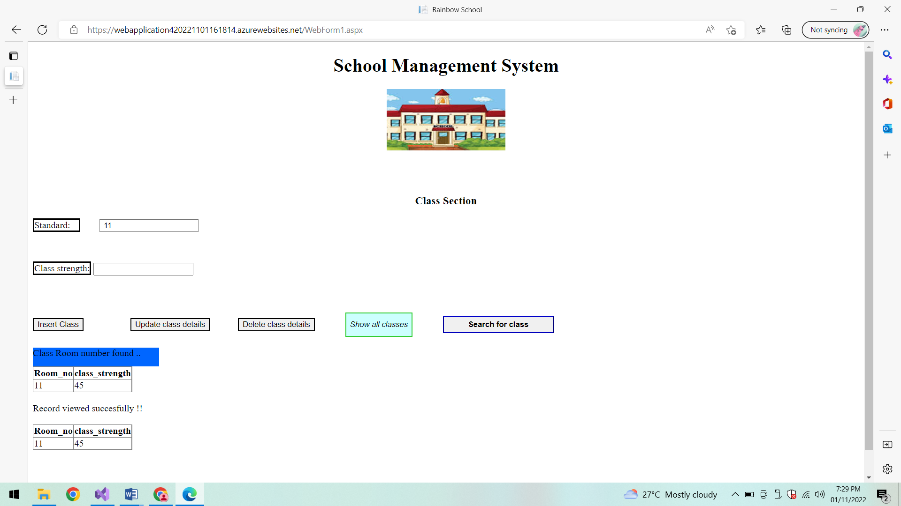

**Student section:**

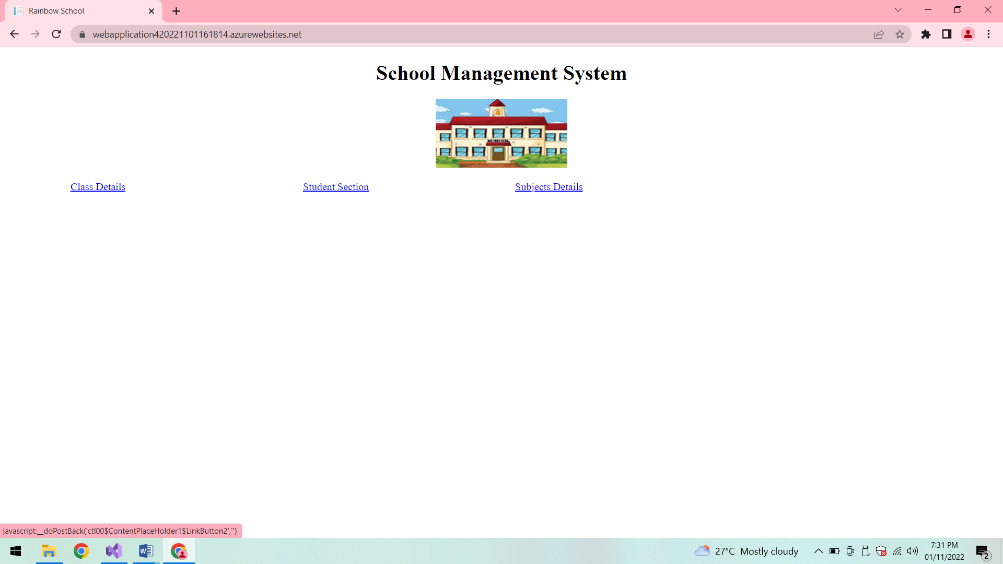

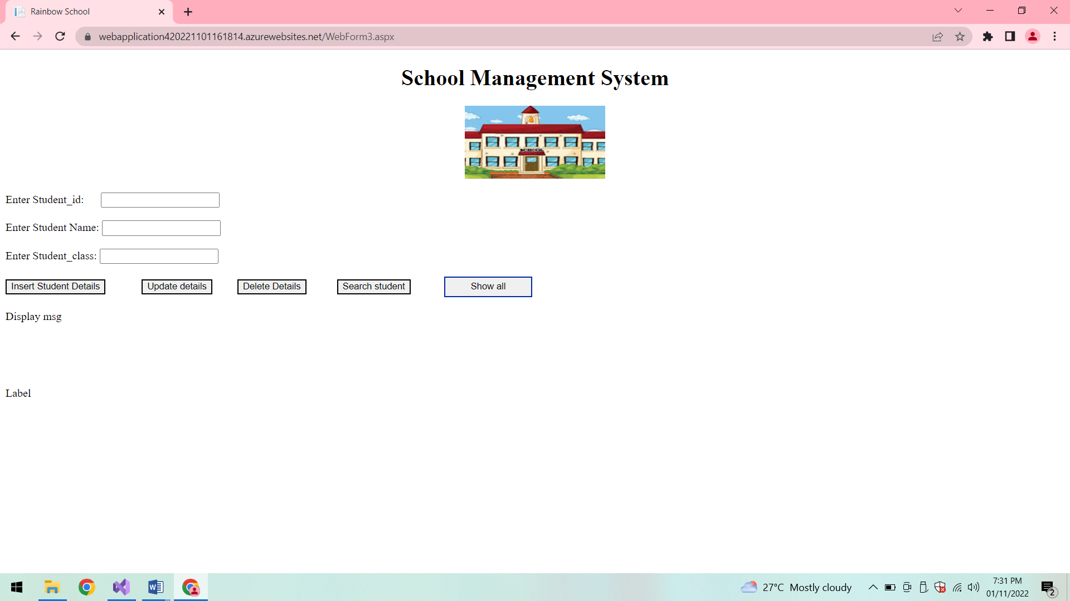

**Show students:**

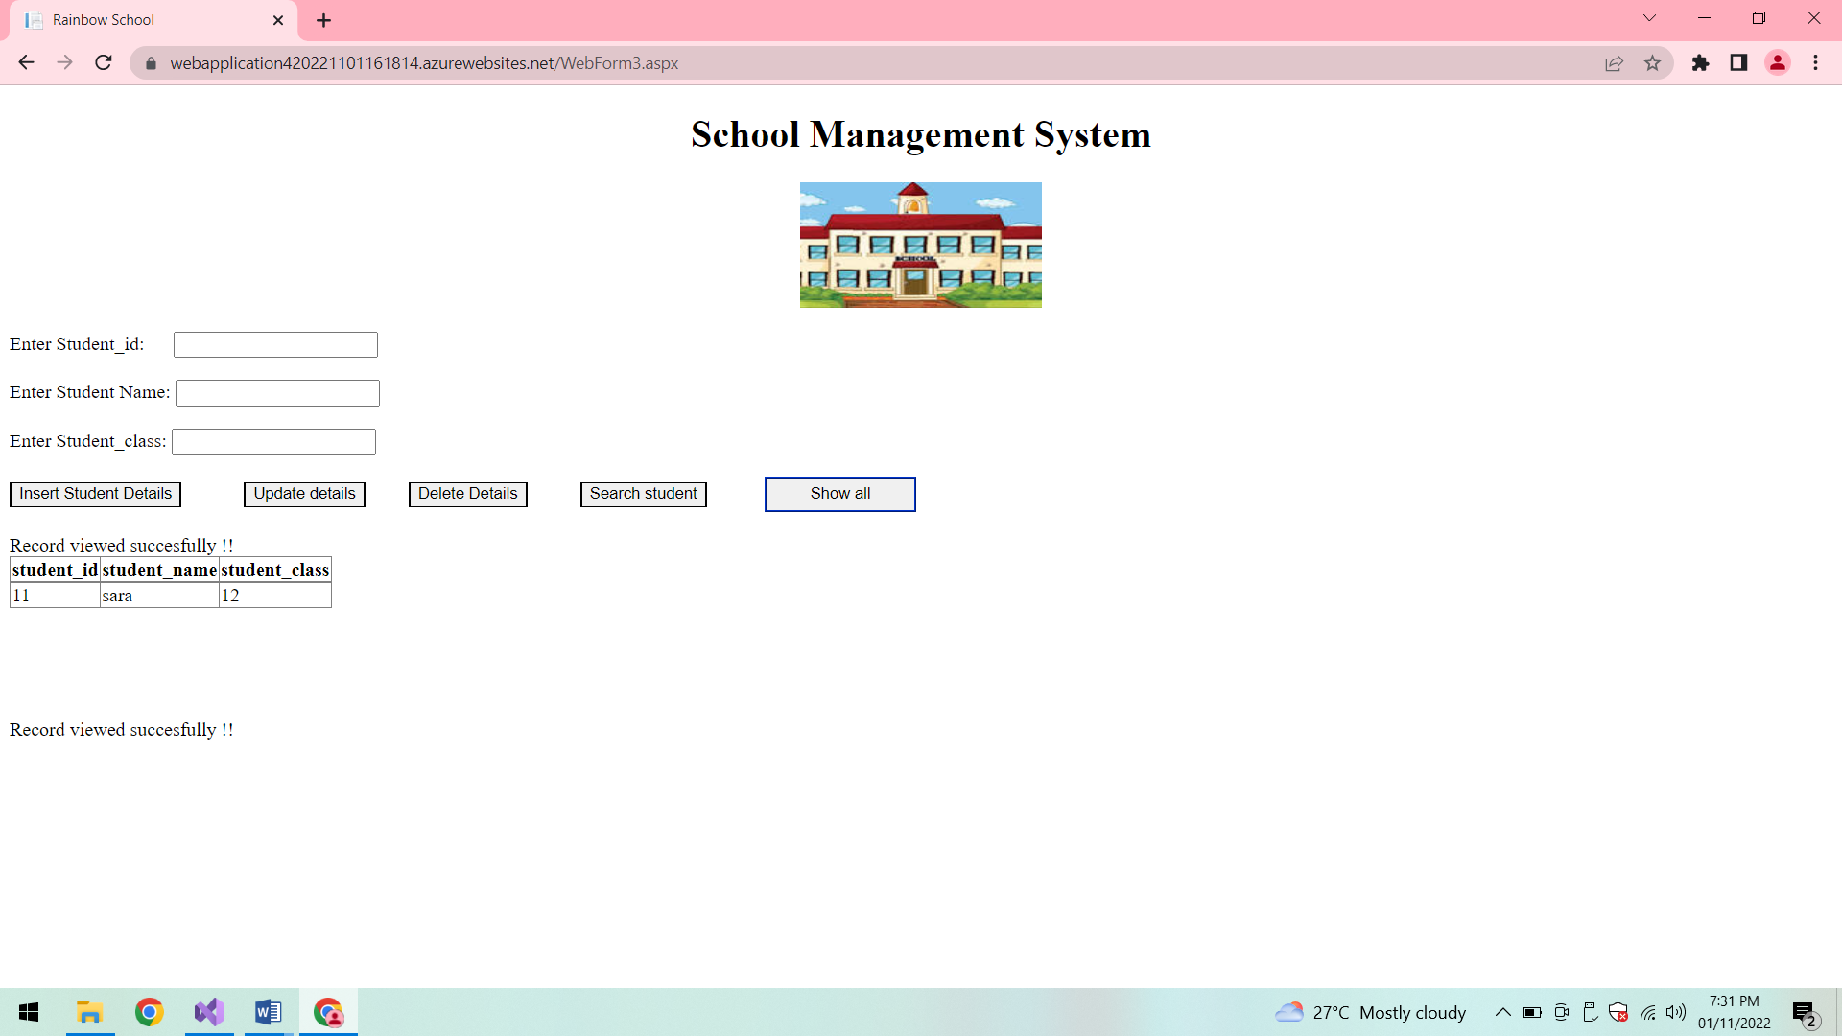

**Insert student details:**

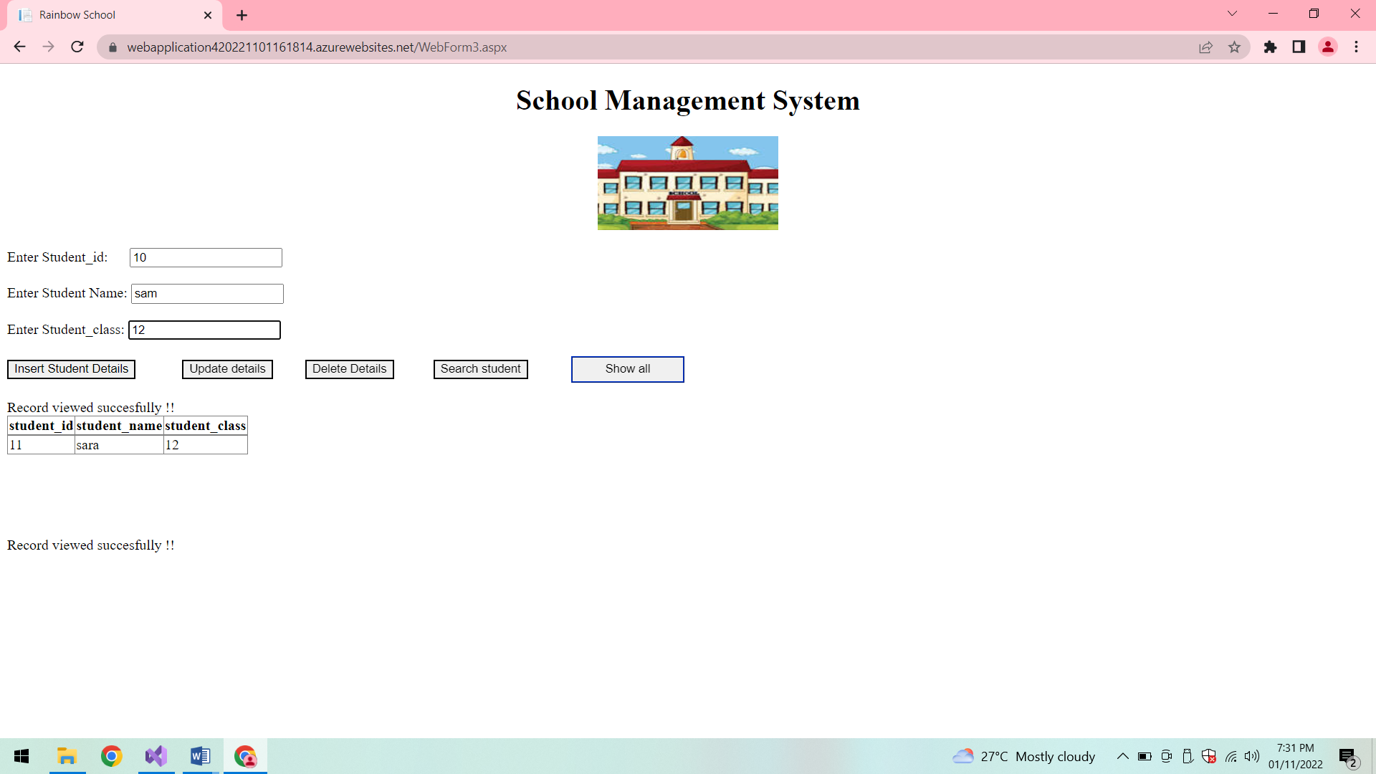

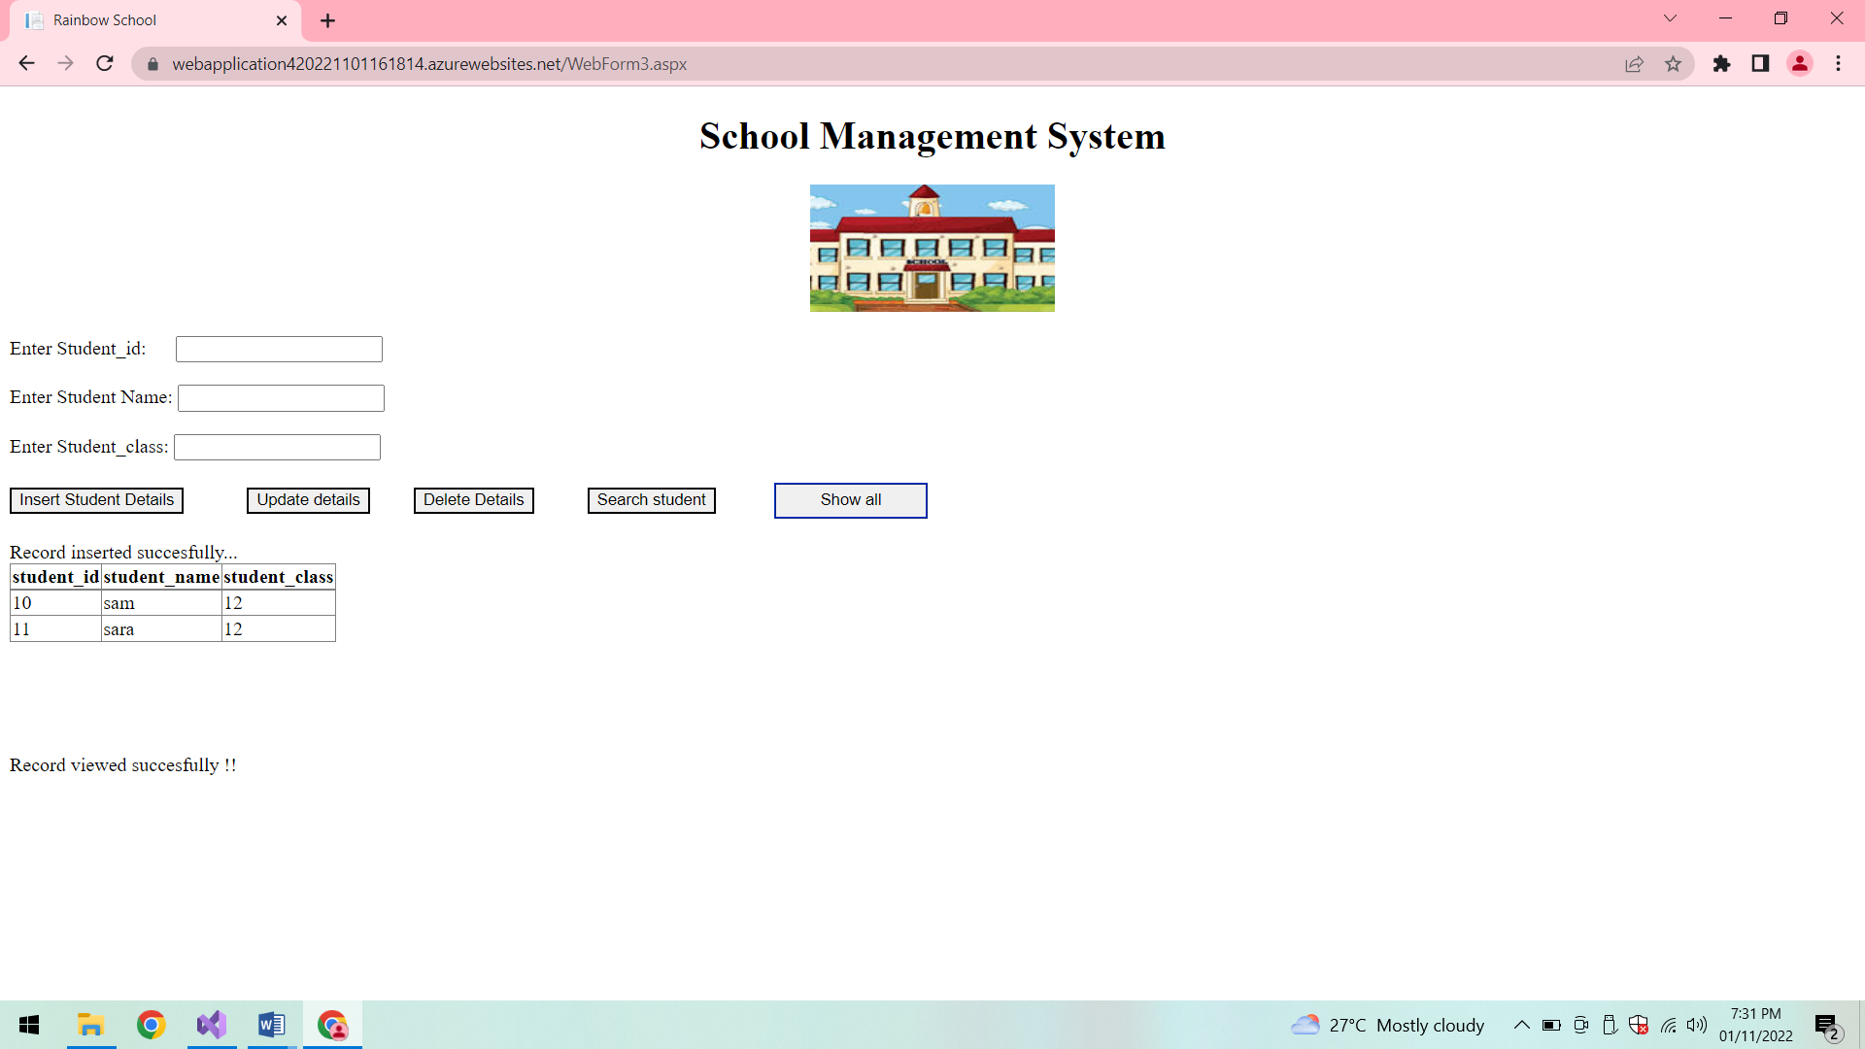

**Update student details:**

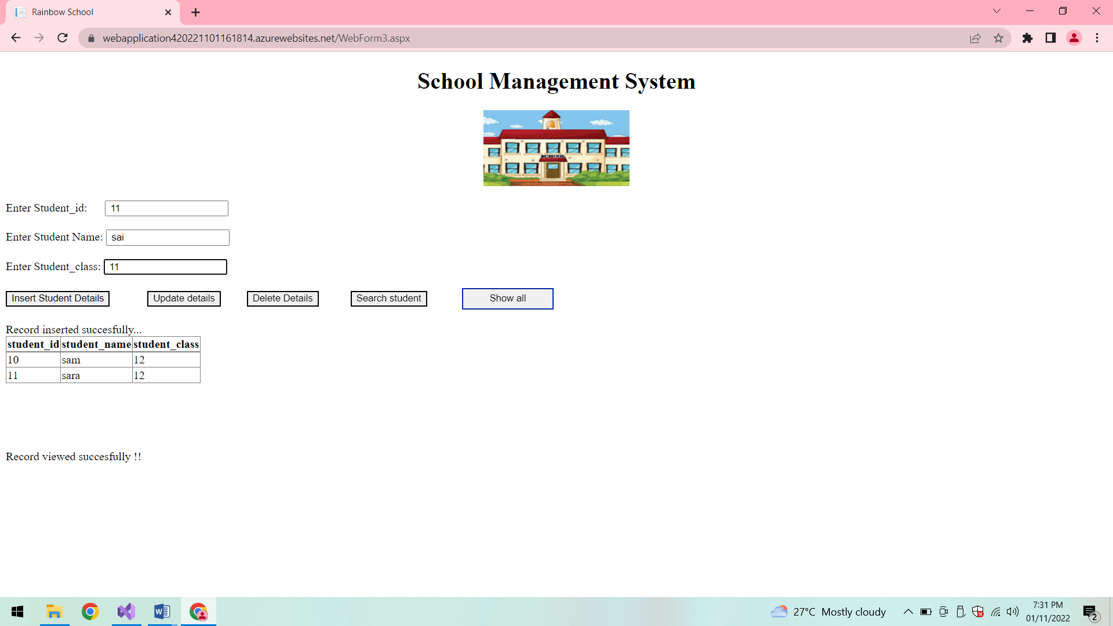

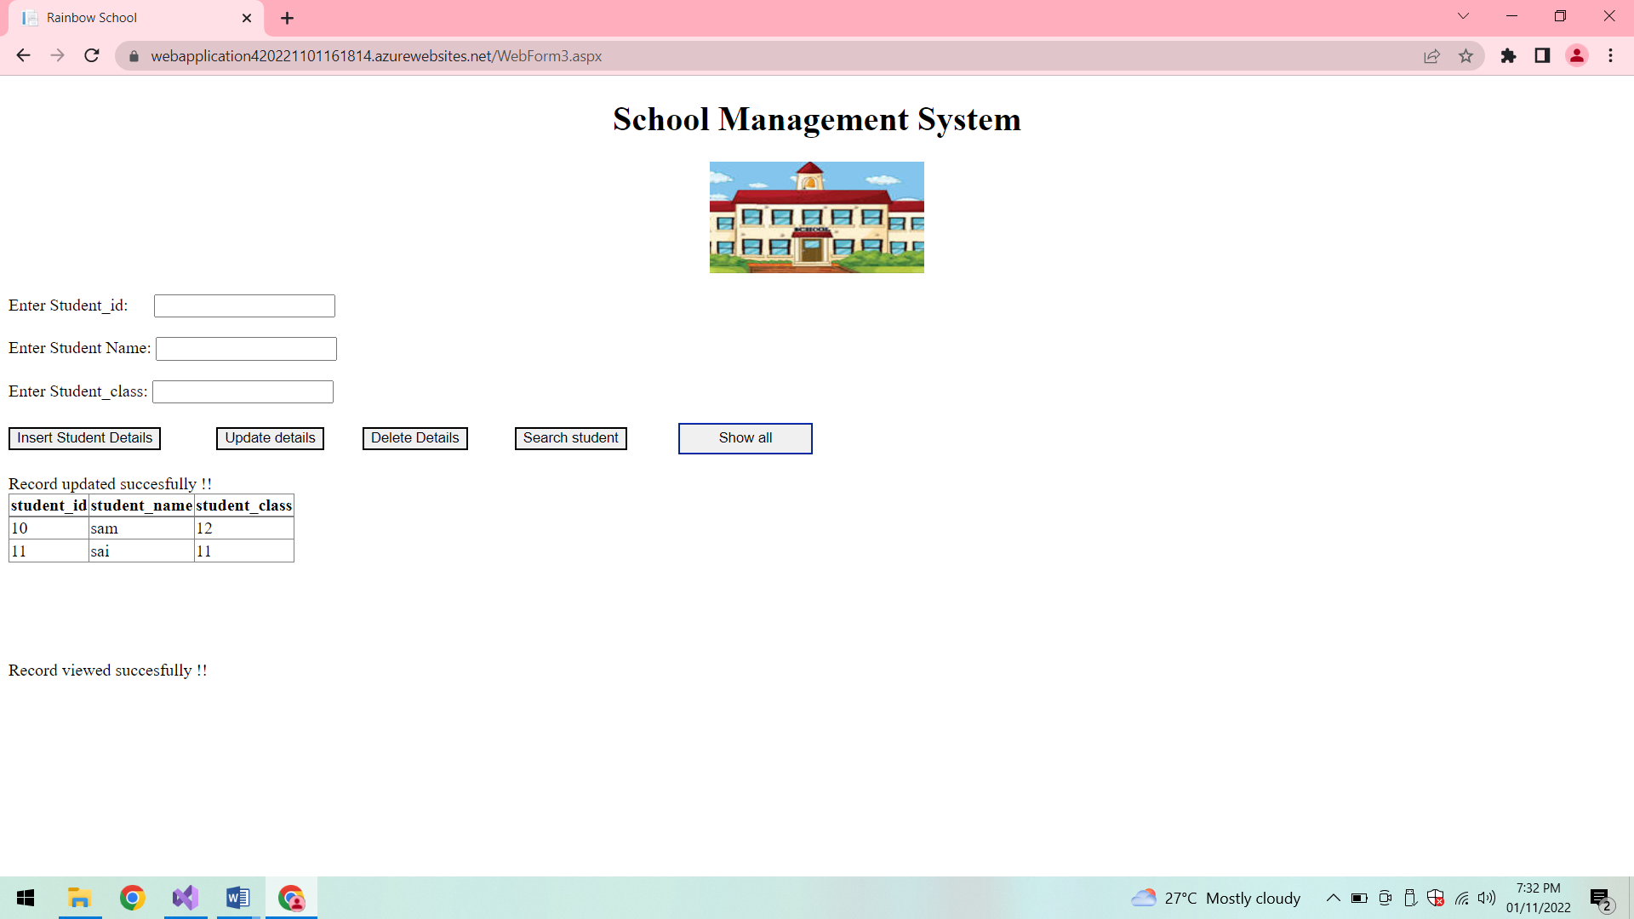

**Show all:**

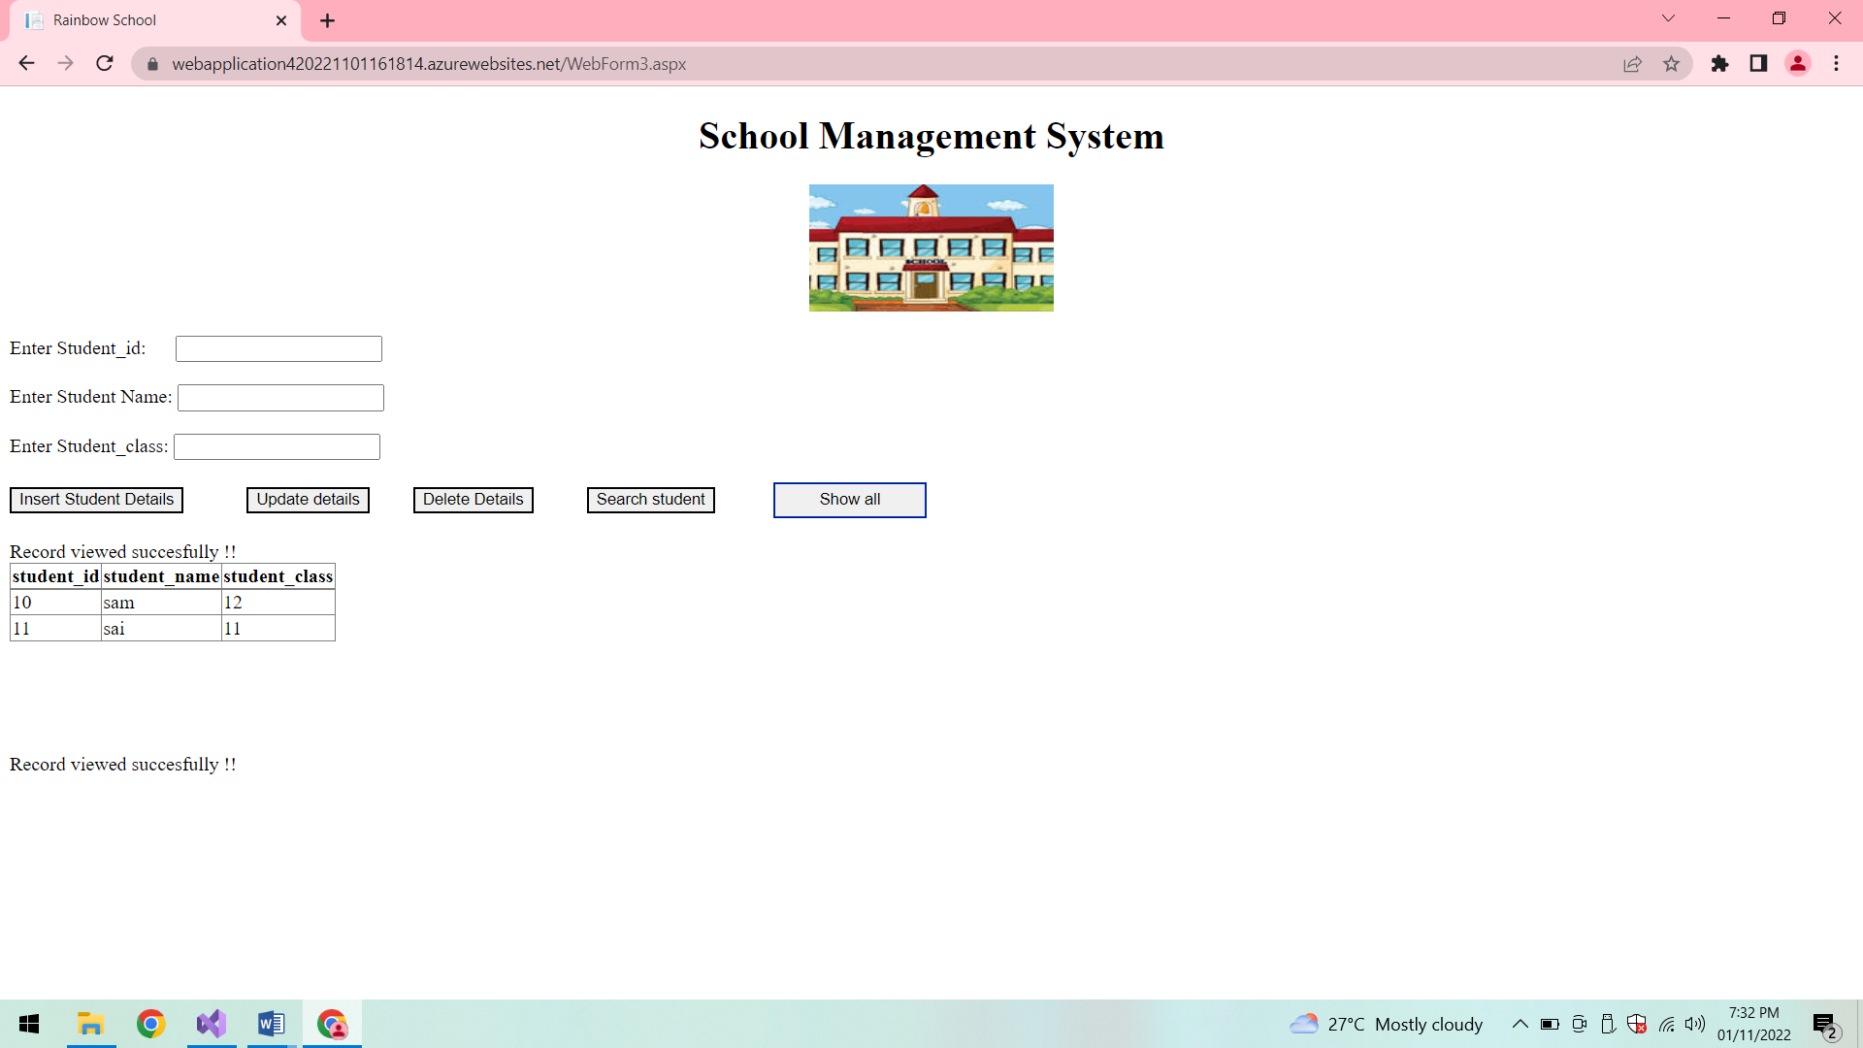

**Delete details:**

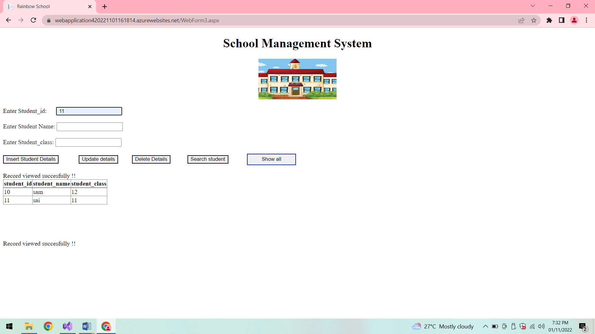

**After Deletion:**

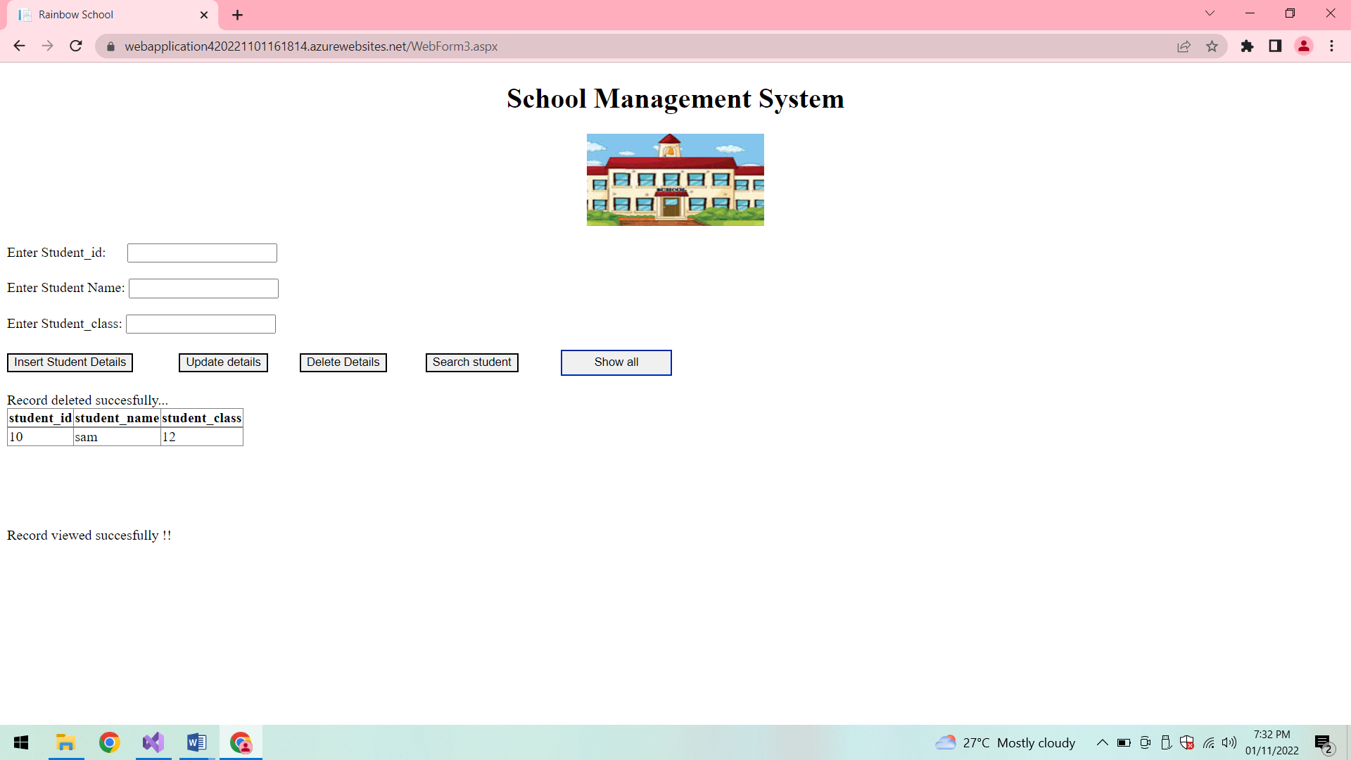

**Search student:**

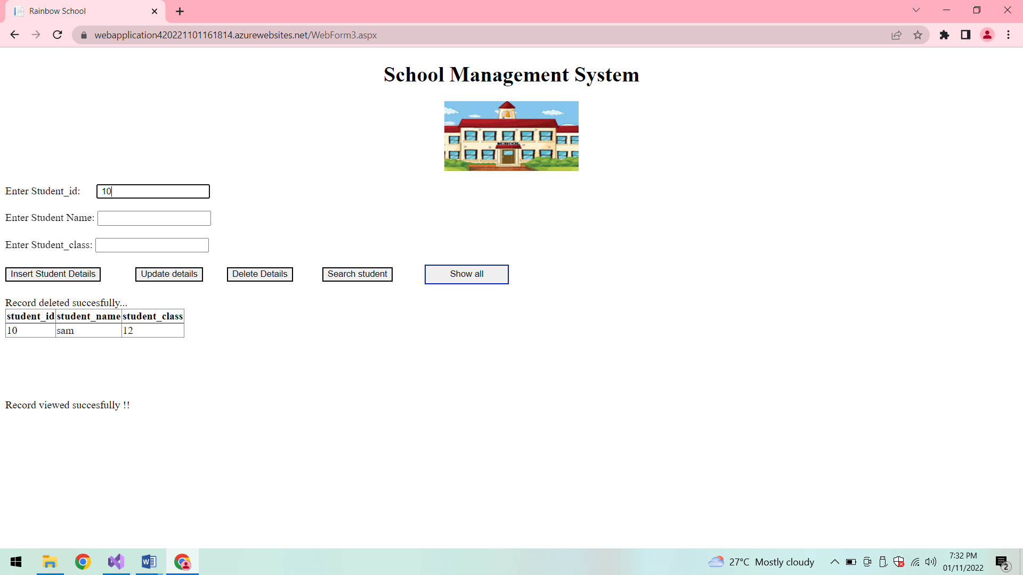

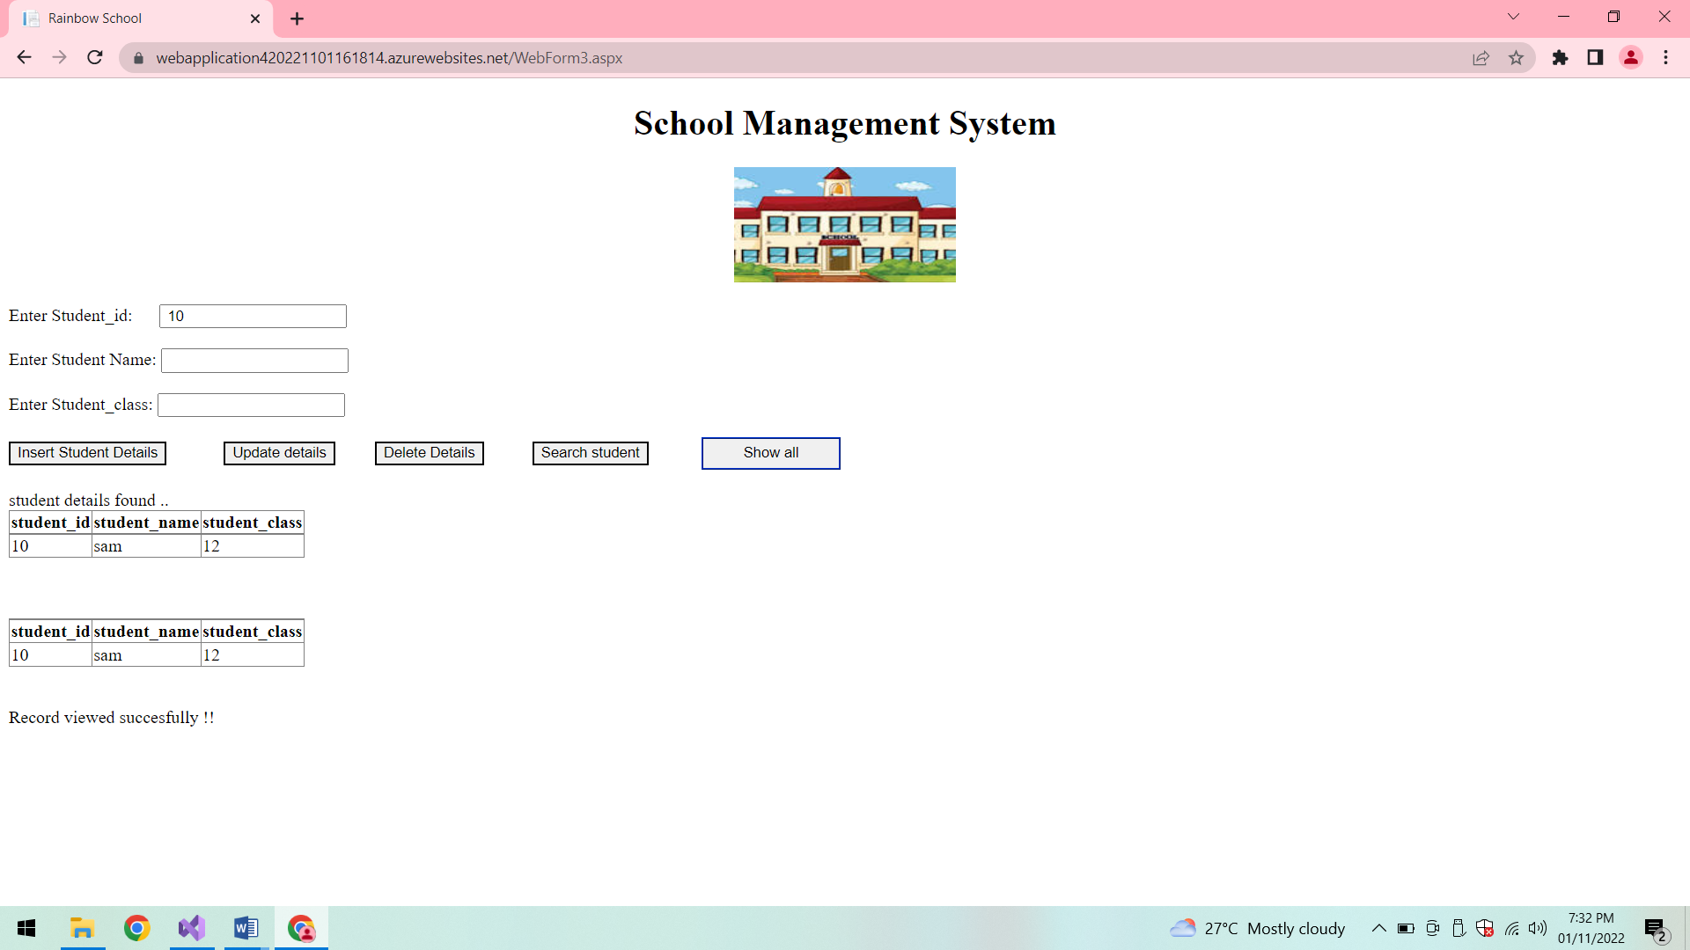

**Subjects Details:**

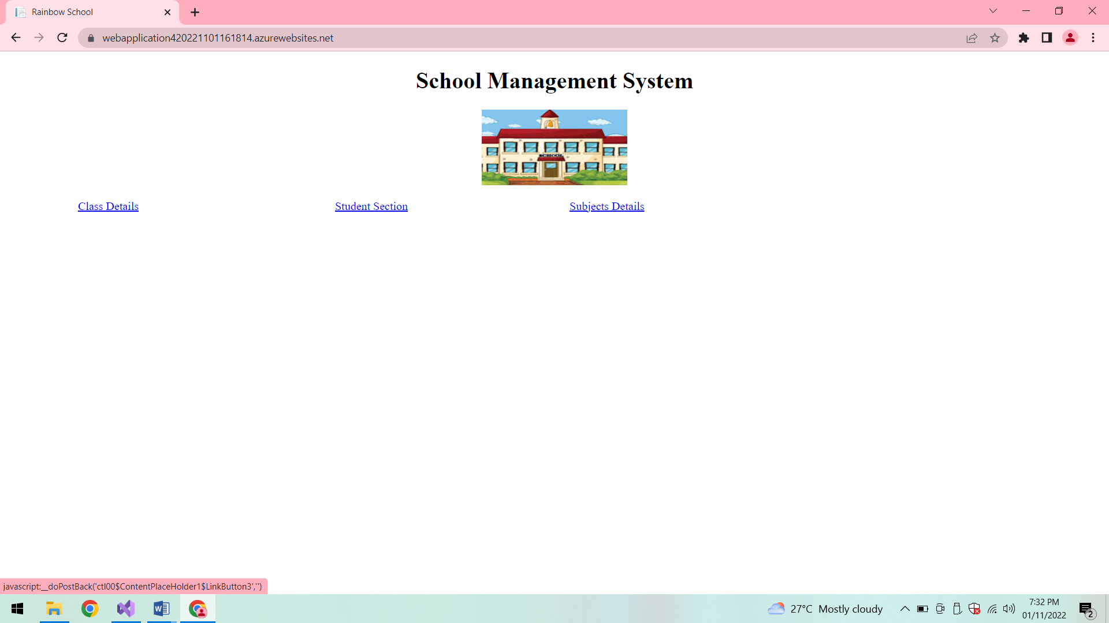

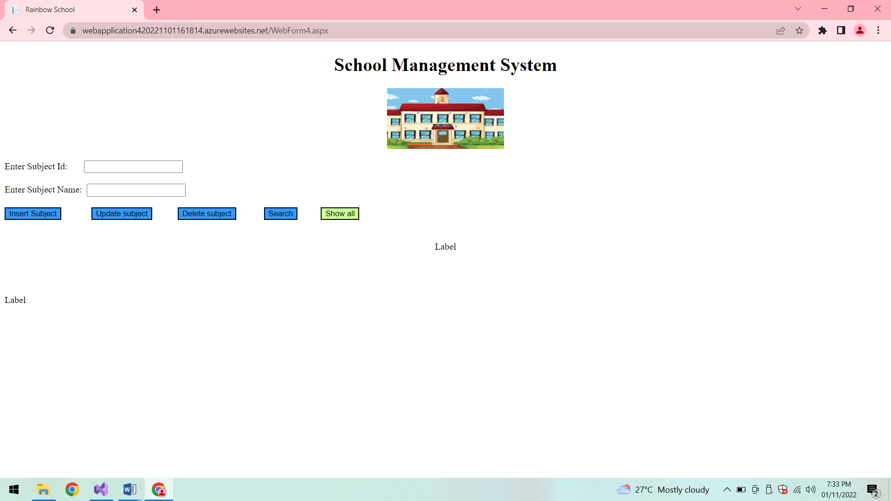

**Show all:**

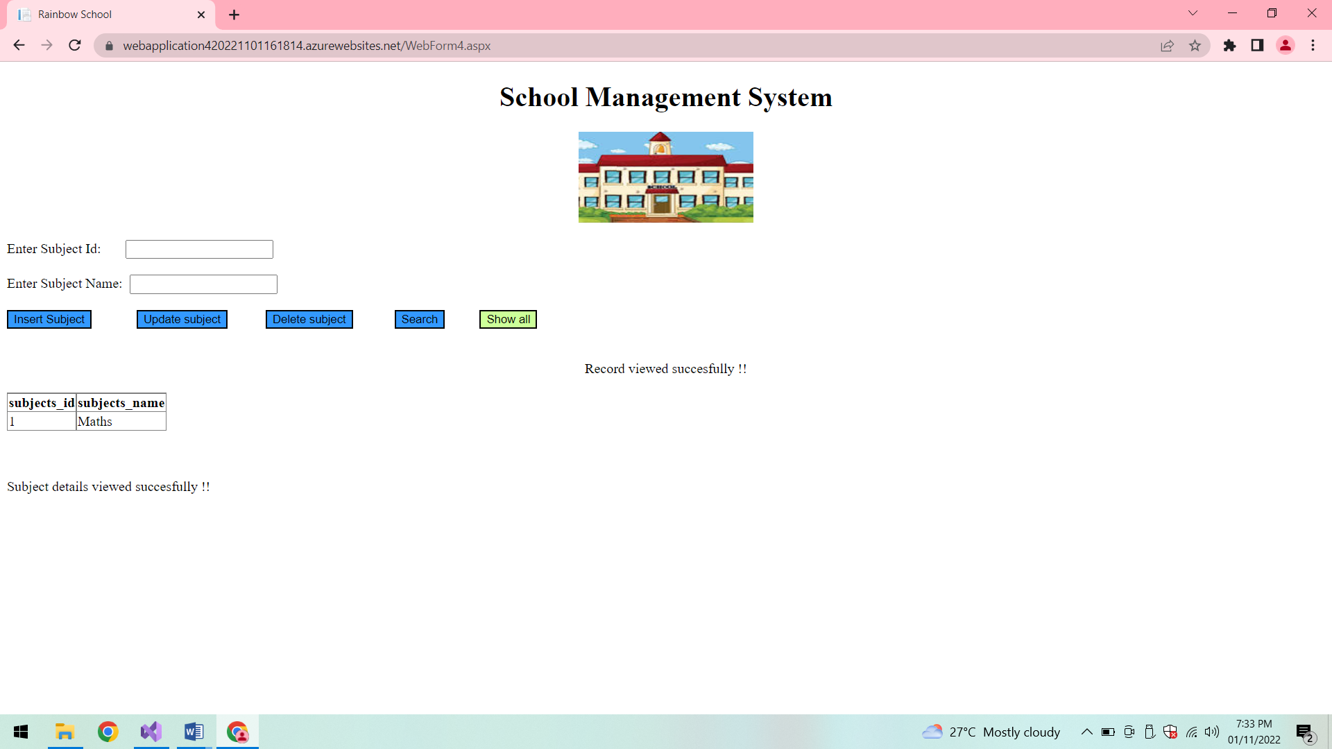

**Insert subjects:**

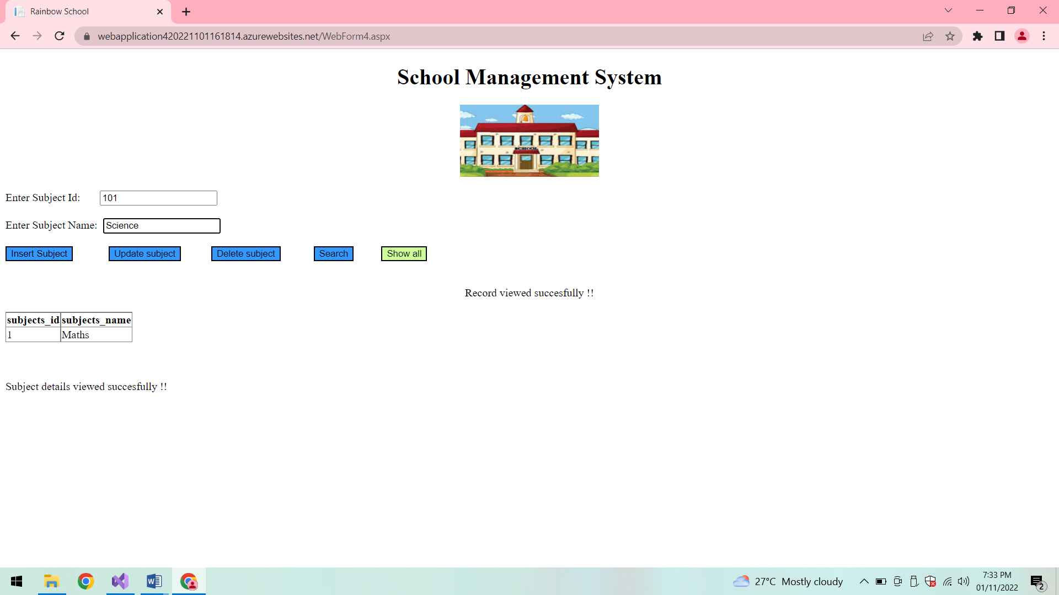

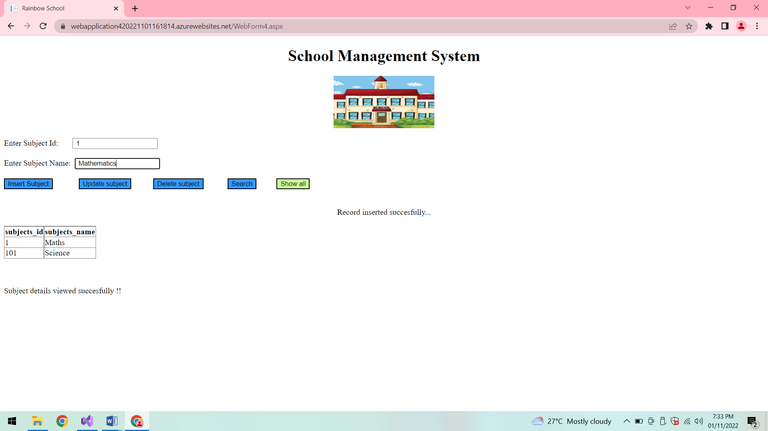

**Update subjects:**



**After updation:**

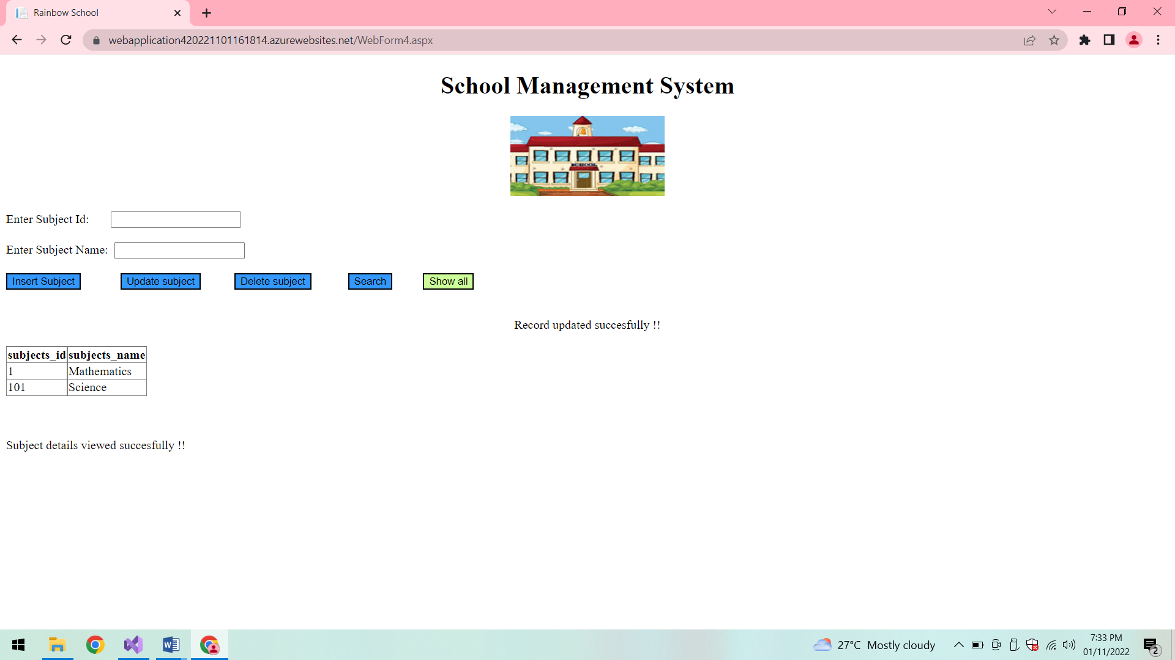

**Search subject:**

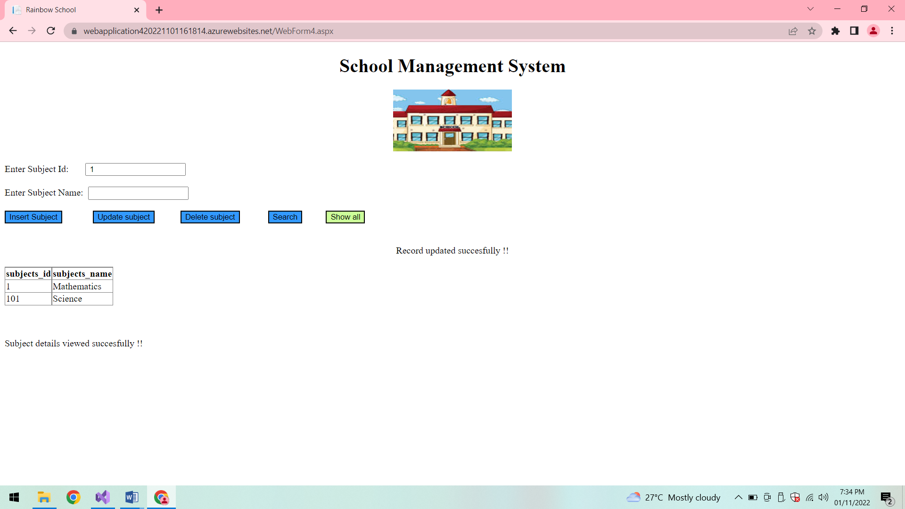

**Subject found:**

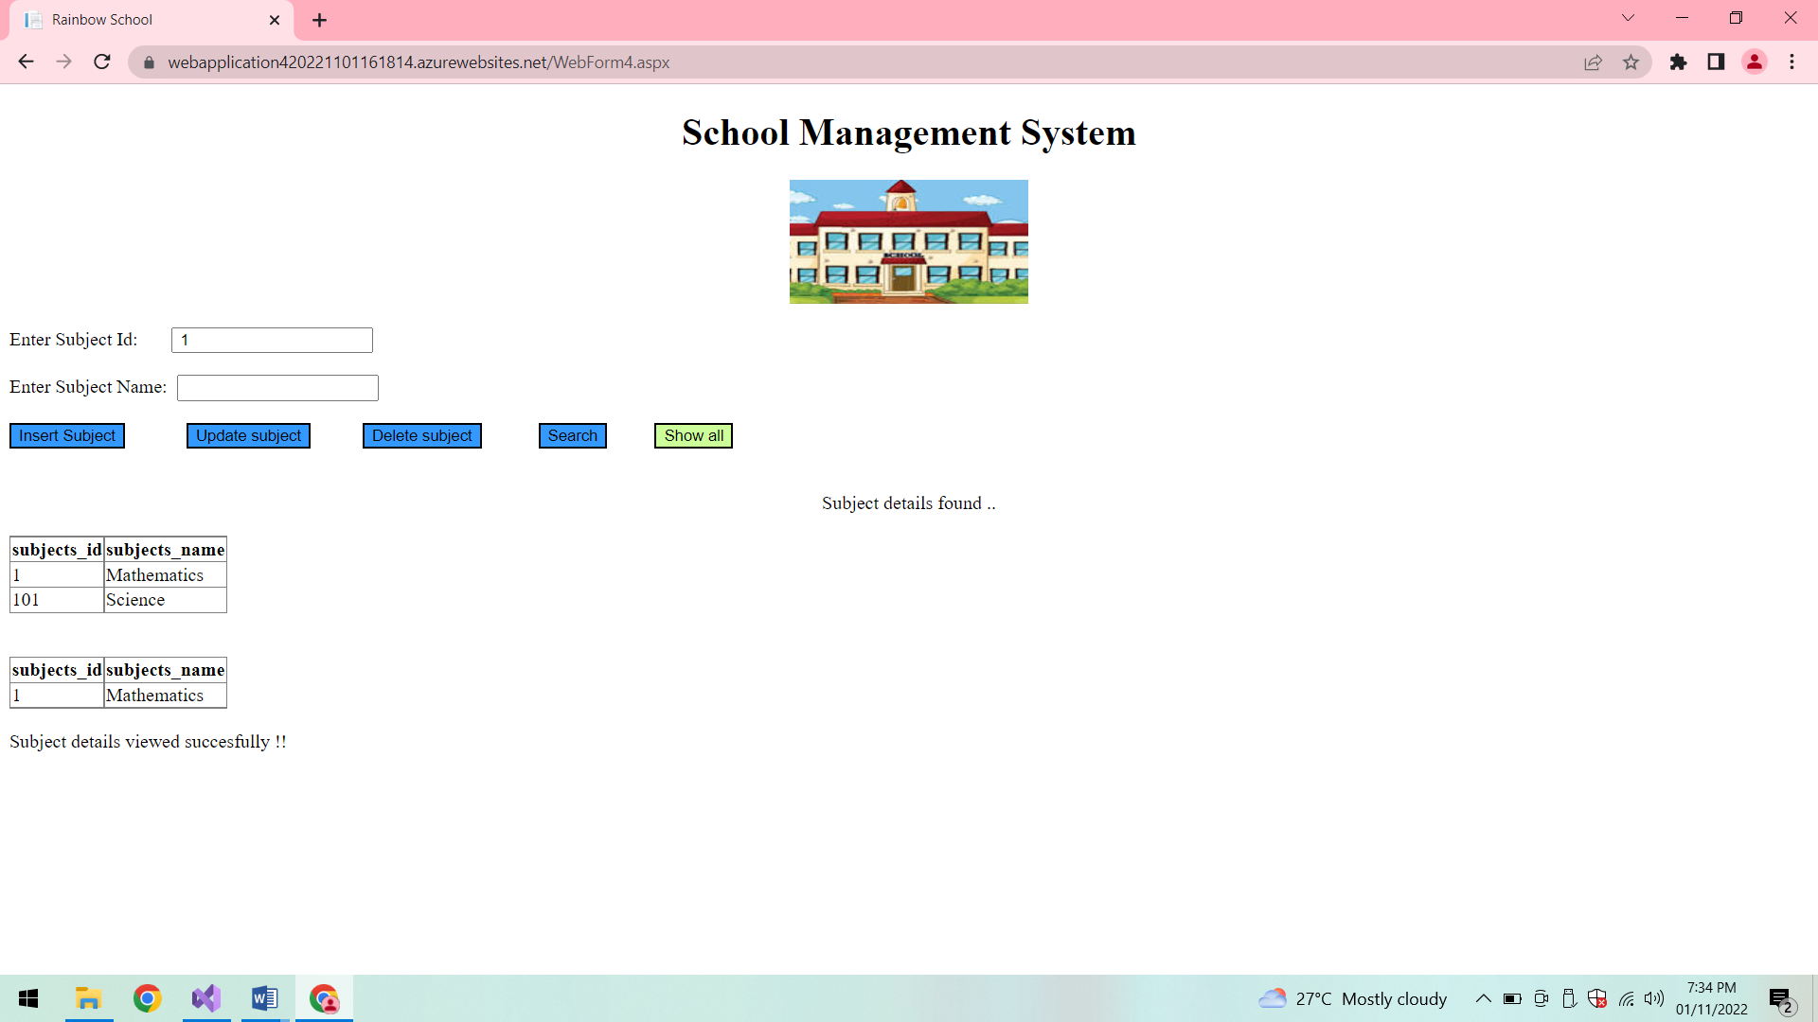

**Delete subject:**

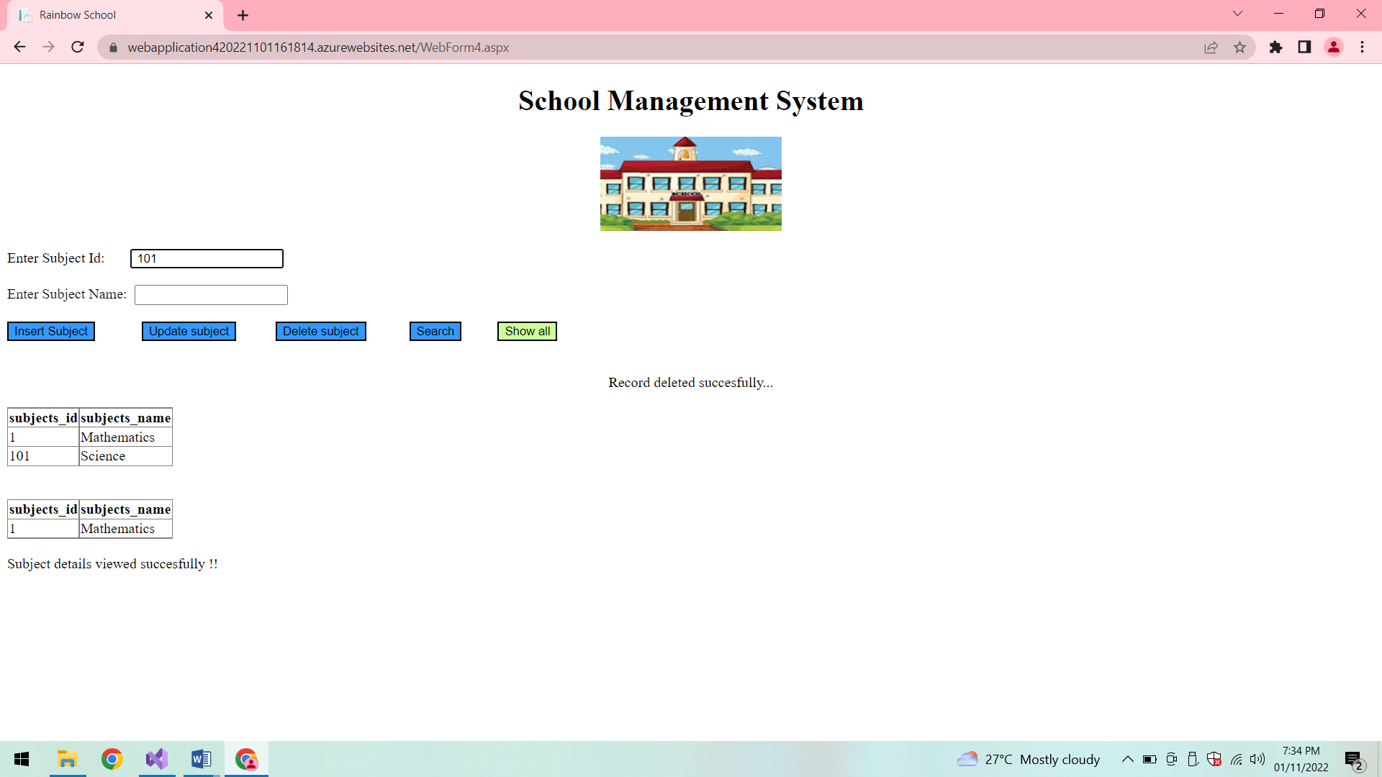

**After deletion:**

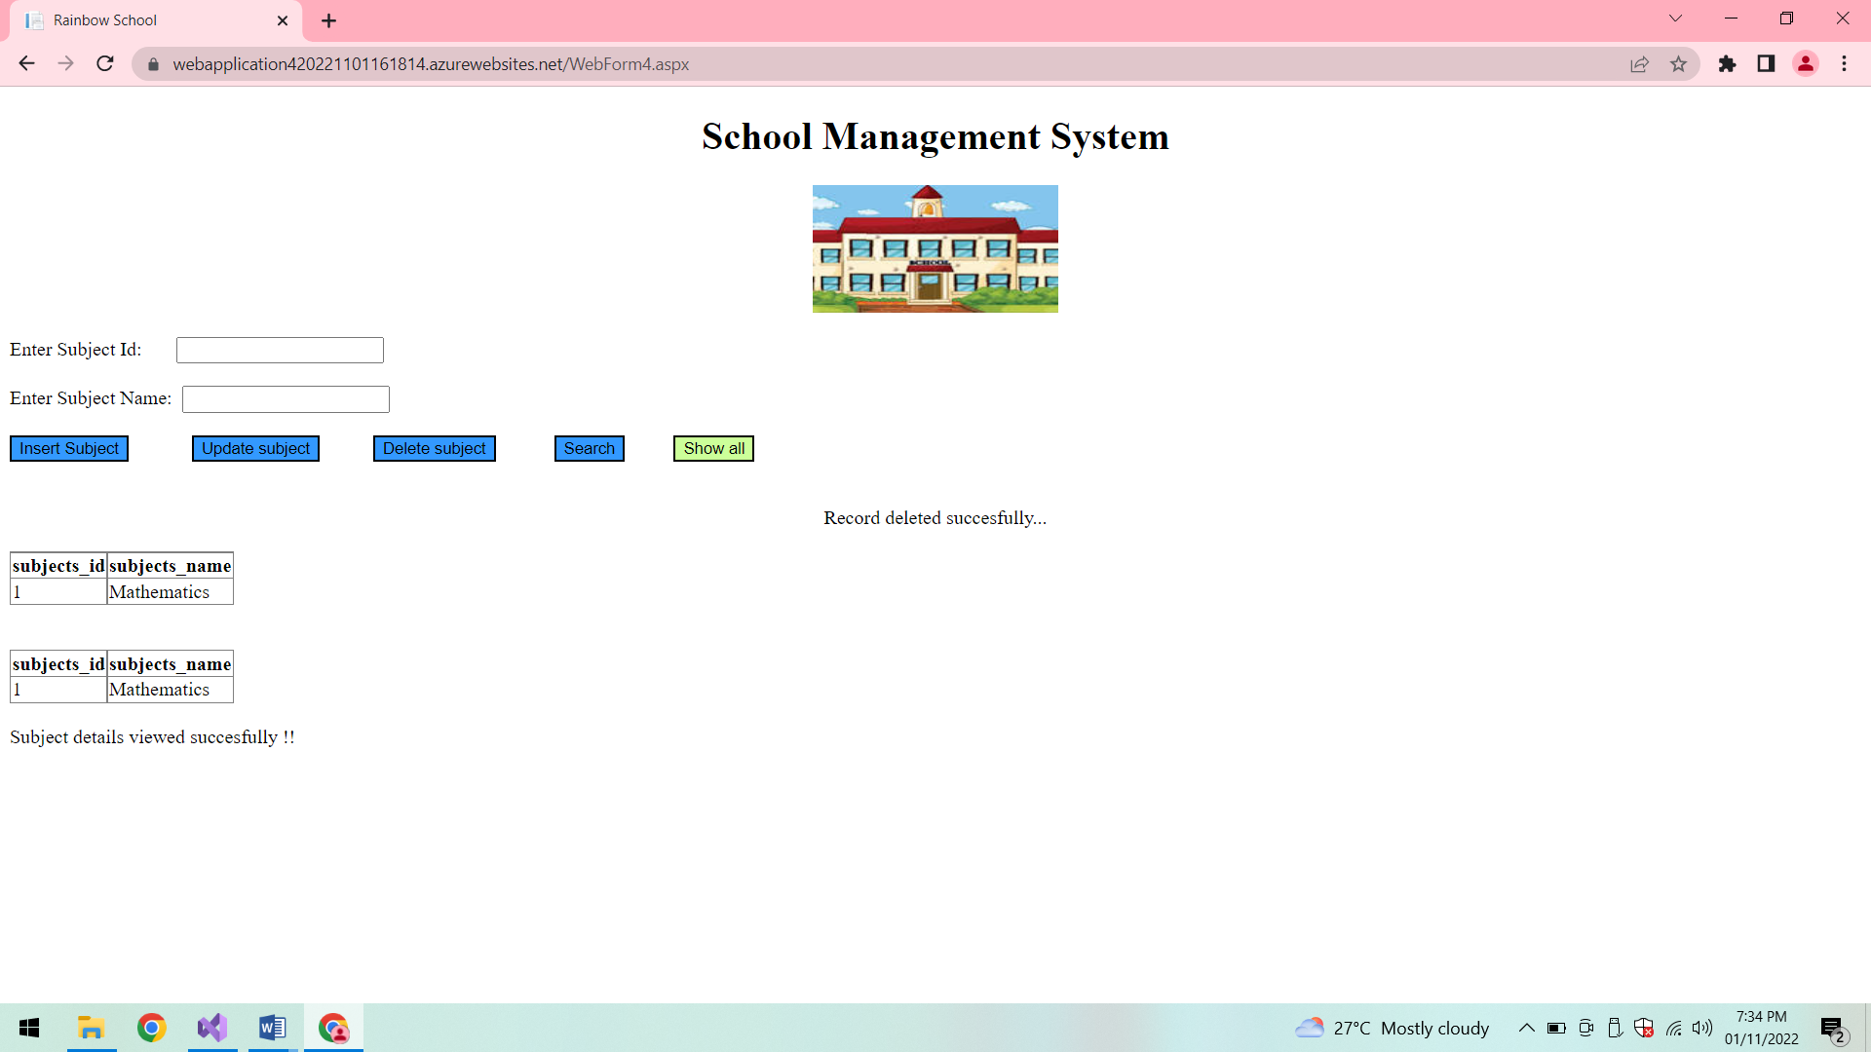

**Publish:**

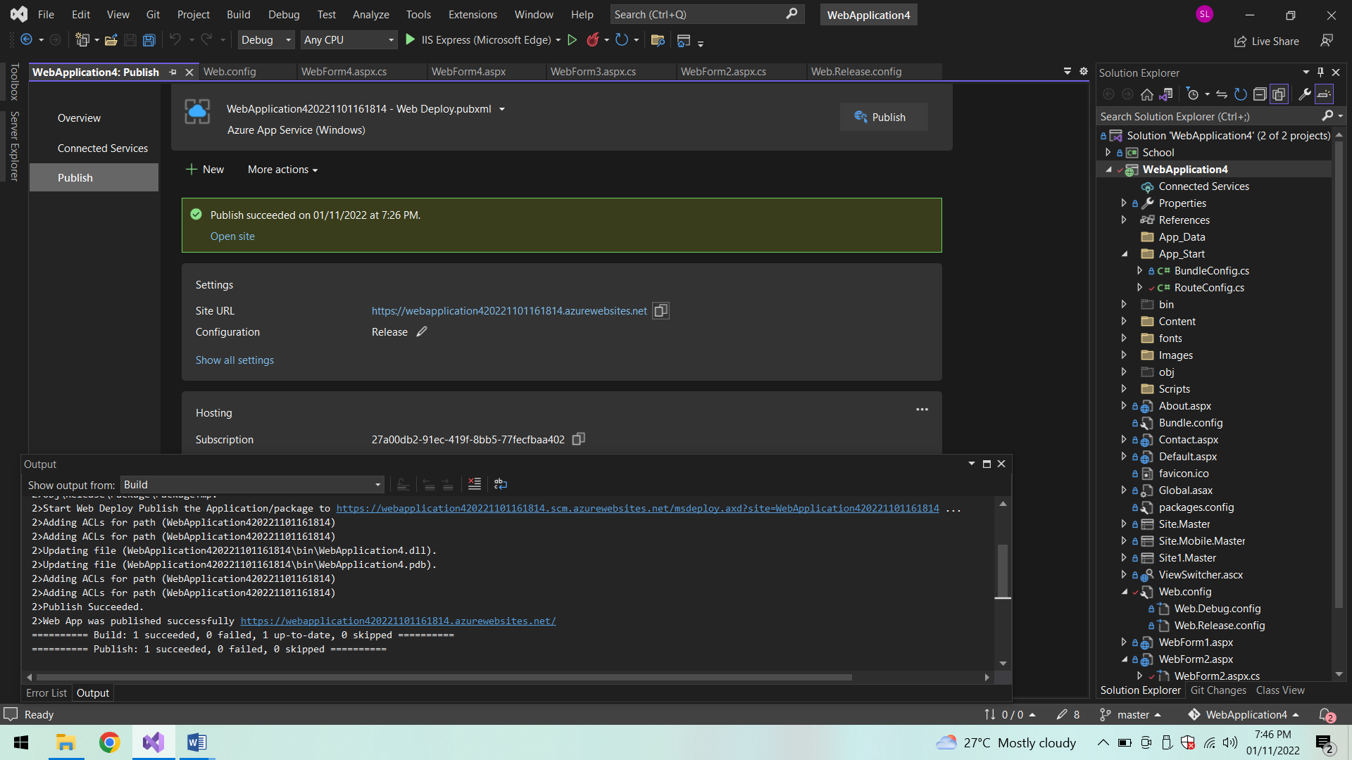

**Conclusion:**

Thus the ASP.NET WebForms application is locally built and deployed it to a VM on Azure.